**Deploying artifacts on kubernetes cluster**

**1) Installing required plugins on jenkins:**

As I had installation error on aws platform so I have used edureka lab to perform task 4 that is deploying artifacts on kubernetes

For that I have install plugin publish over ssh as shown in screenshot below

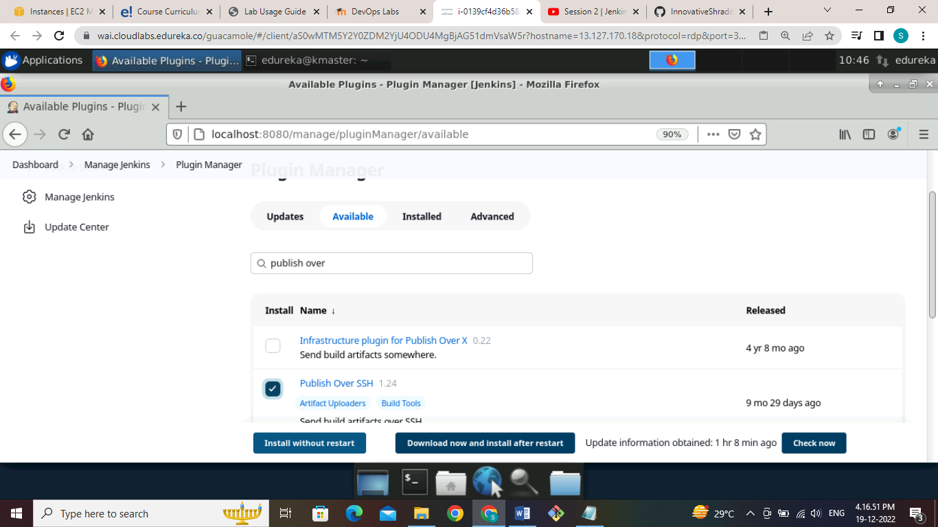

Here we can see that our plugins install successful as shown in screenshot

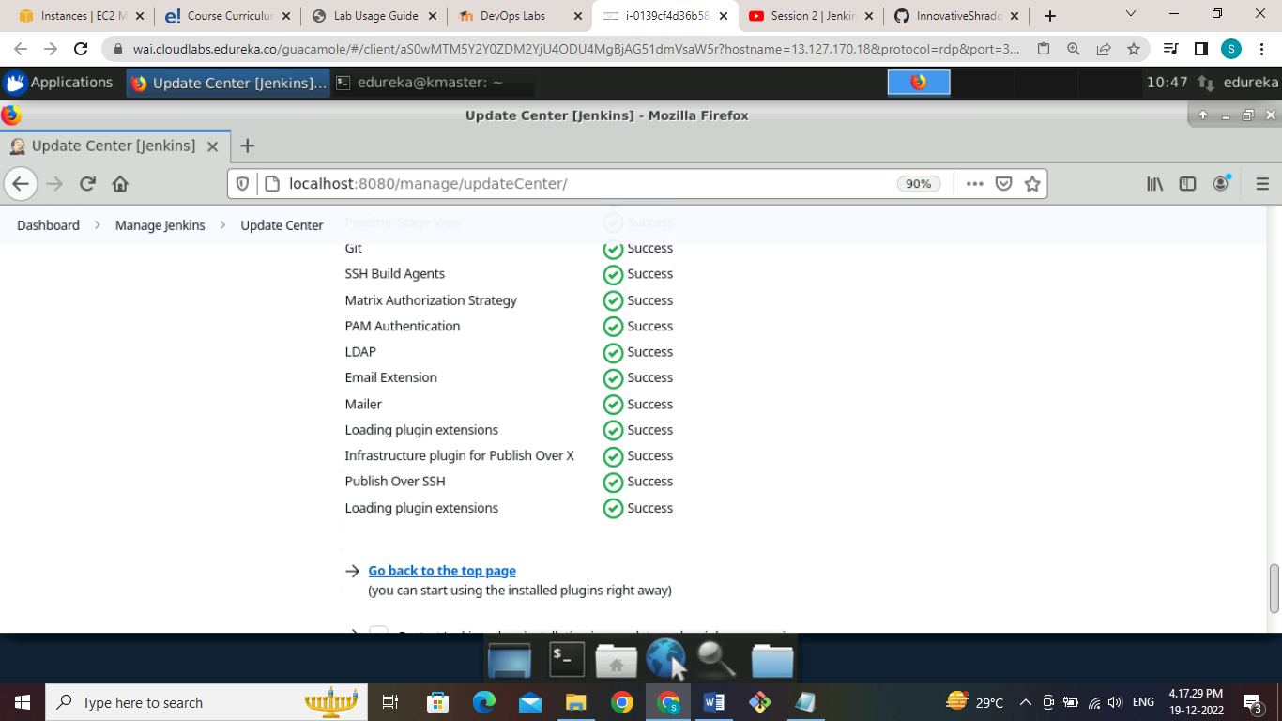

We also need some other plugins to run our ansible Playbook for that I have install ansible plugin to run playbooks

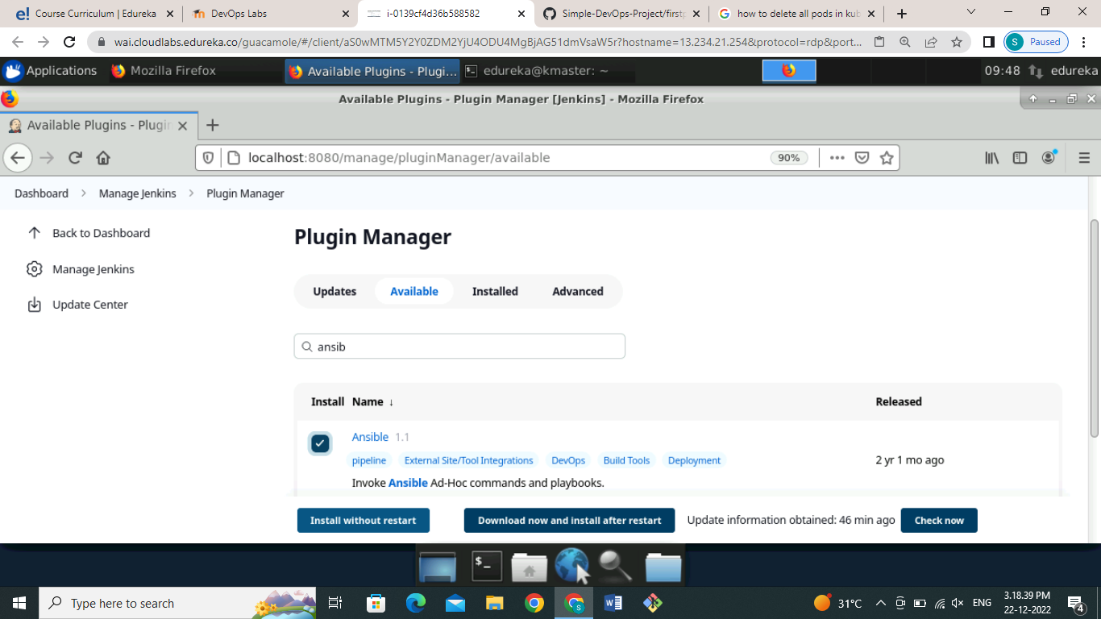

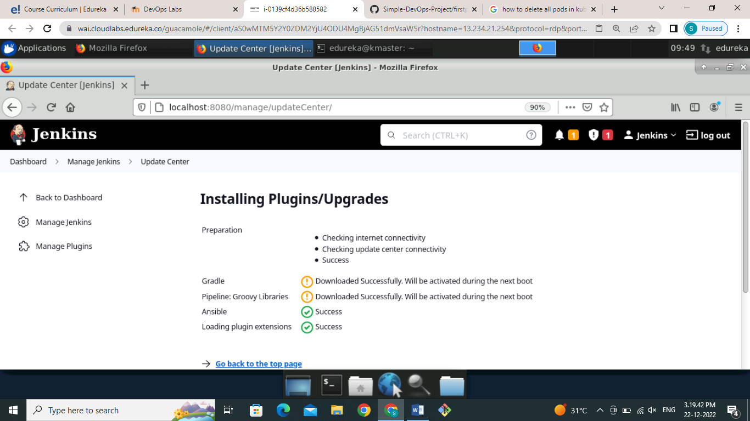

After successful installation of plugins integrated ansible with Jenkins for that I have configure system by ssh server as shown in screenshot

For that I have went to Manage Jenkins >>Configure System >> SSH servers:

Provide name of the server that we want to connect then provide host name or private IP address of the host, username that we want to connect and password of the user or passphrase of the private key and click on test configuration to check connection between Ansible server and Jenkins.

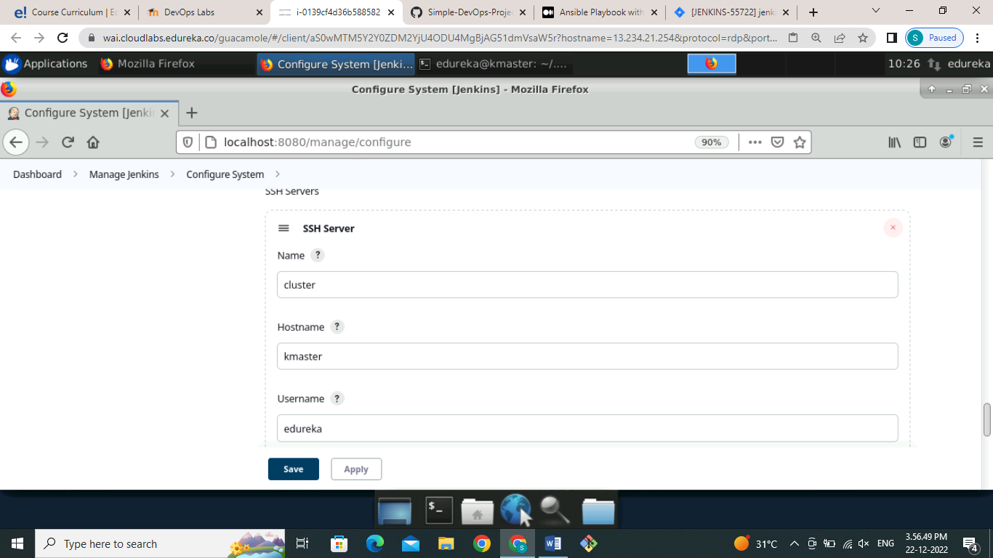

And password of the user or passphrase of the private key and click on test configuration to check connection between ansible server and Jenkins

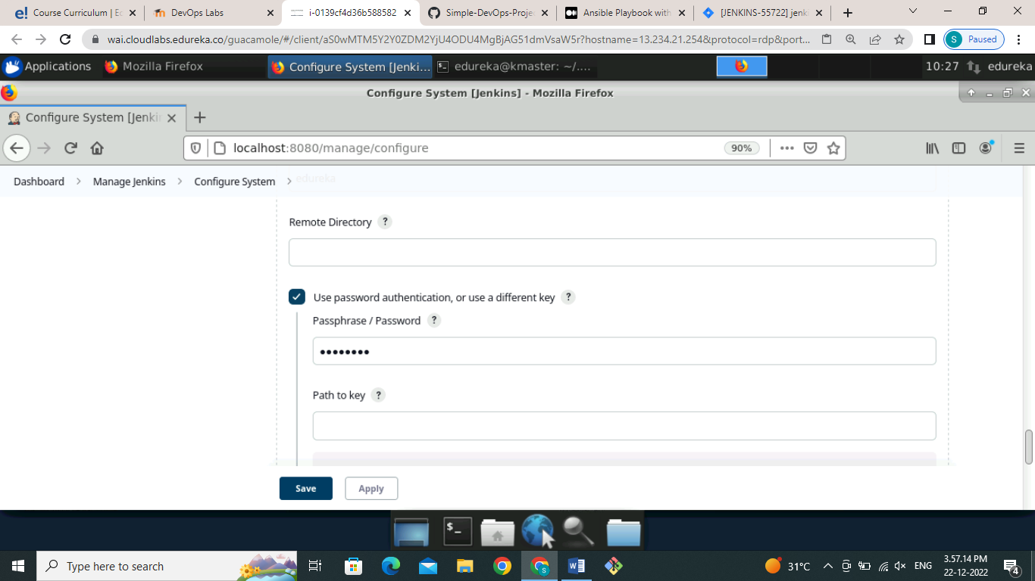

Here we can see that our connection is established successfully as shown in screenshot

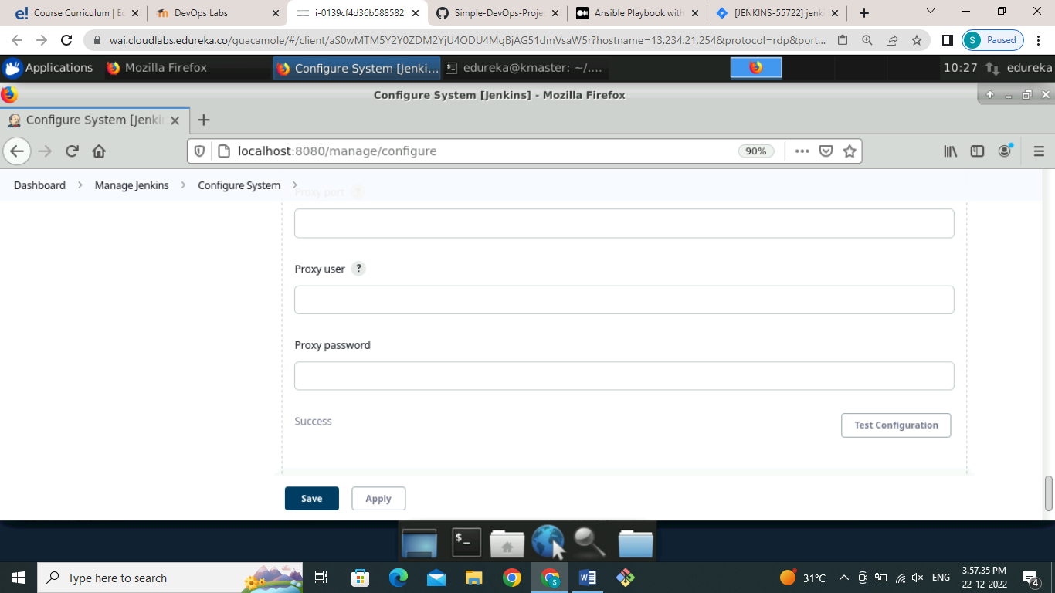

**2) Pushing image to dockerhub registry:**

First we will create Jenkins job to build the project. For that go to Jenkins job create freestyle project and give name as shown in figure

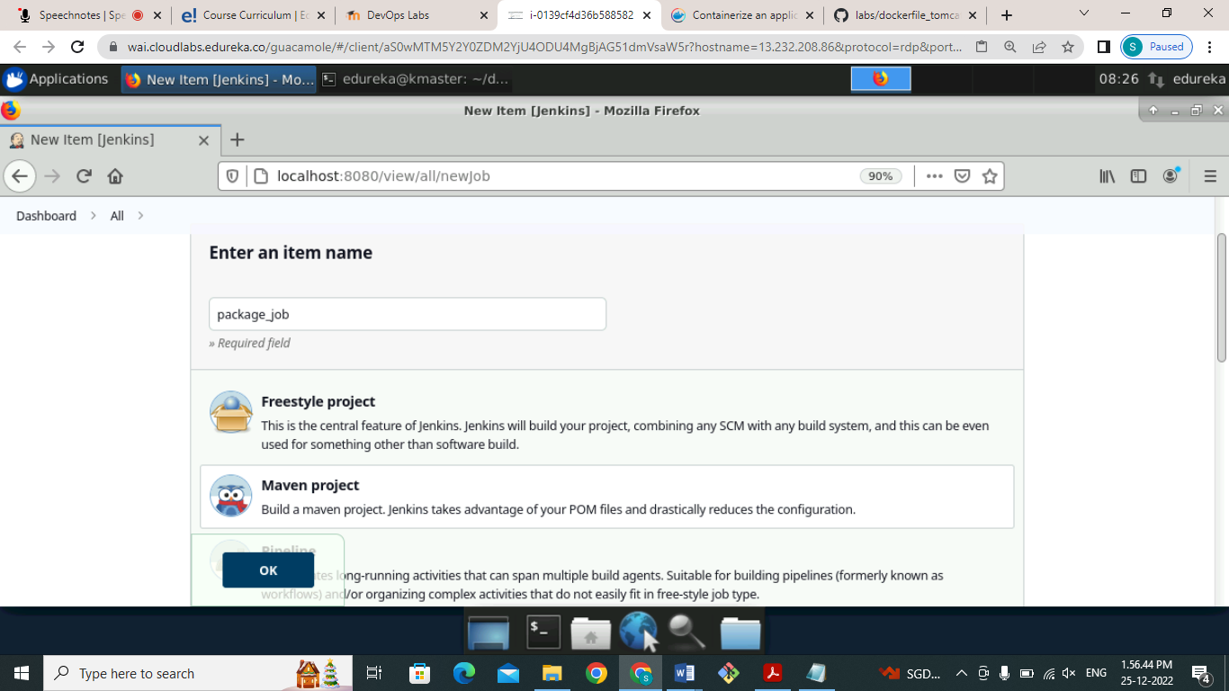

After creating a job go to configure section and give a proper description as this job is for packaging the code from GitHub

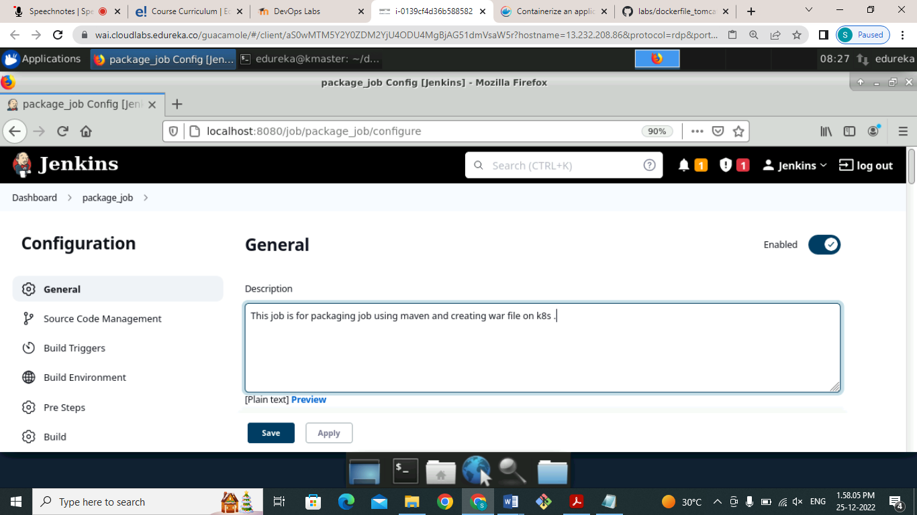

Then go to GitHub repository and copy the source code link from it as shown below

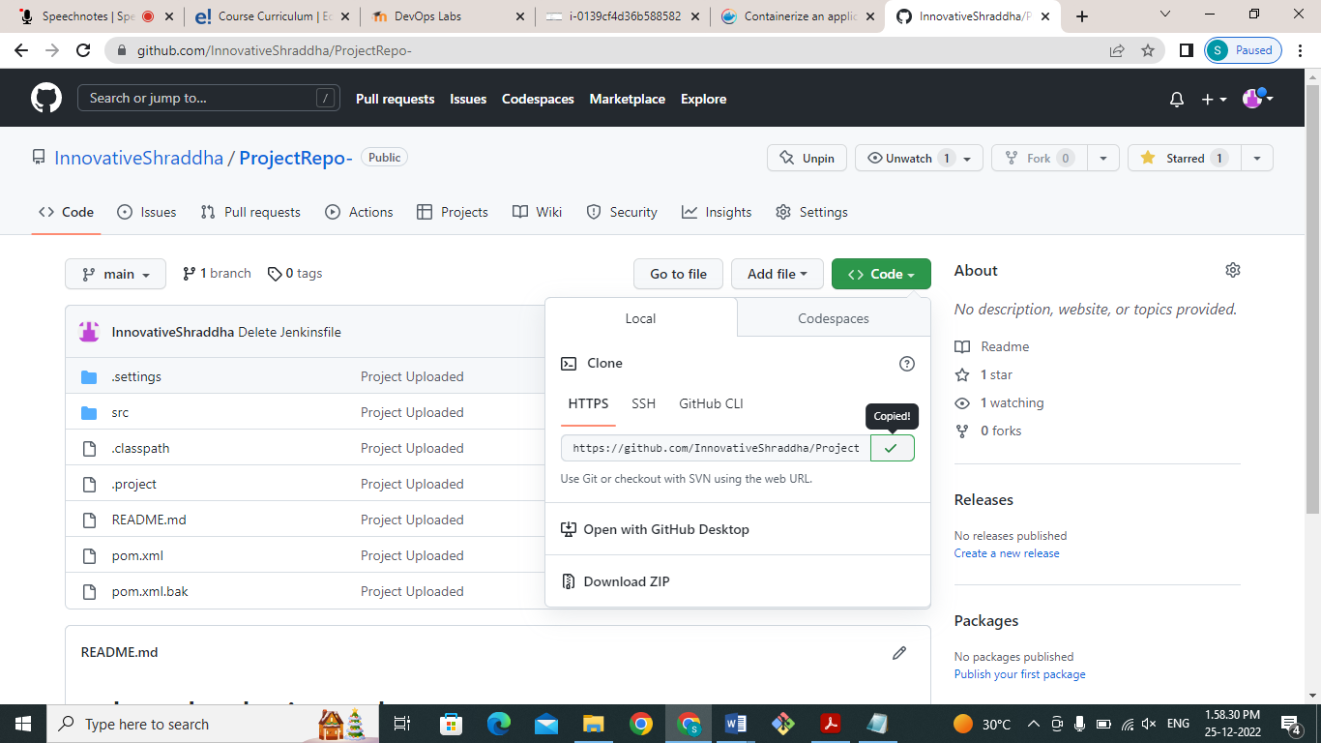

Paste the URL in to source code management section of Git as shown in figure

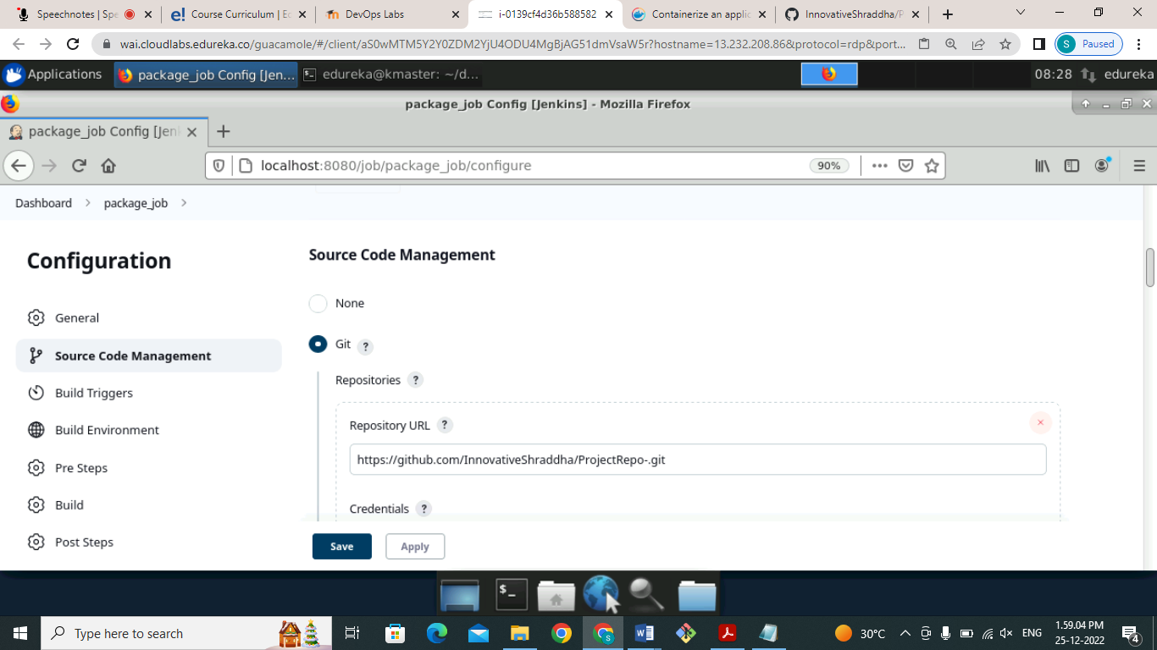

Give a branch name that we want to build of GitHub repository .

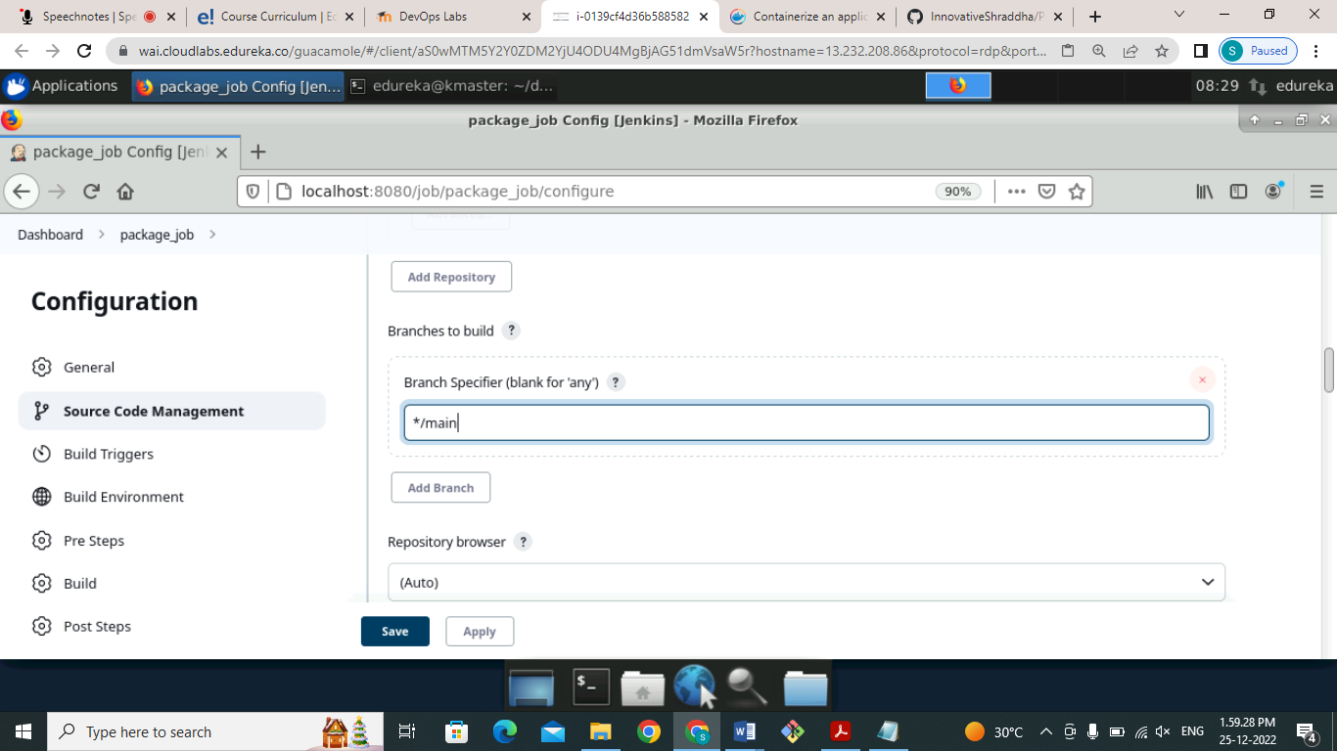

Then go to the build section in that select option invoke top level Maven target and in that give Maven commands below

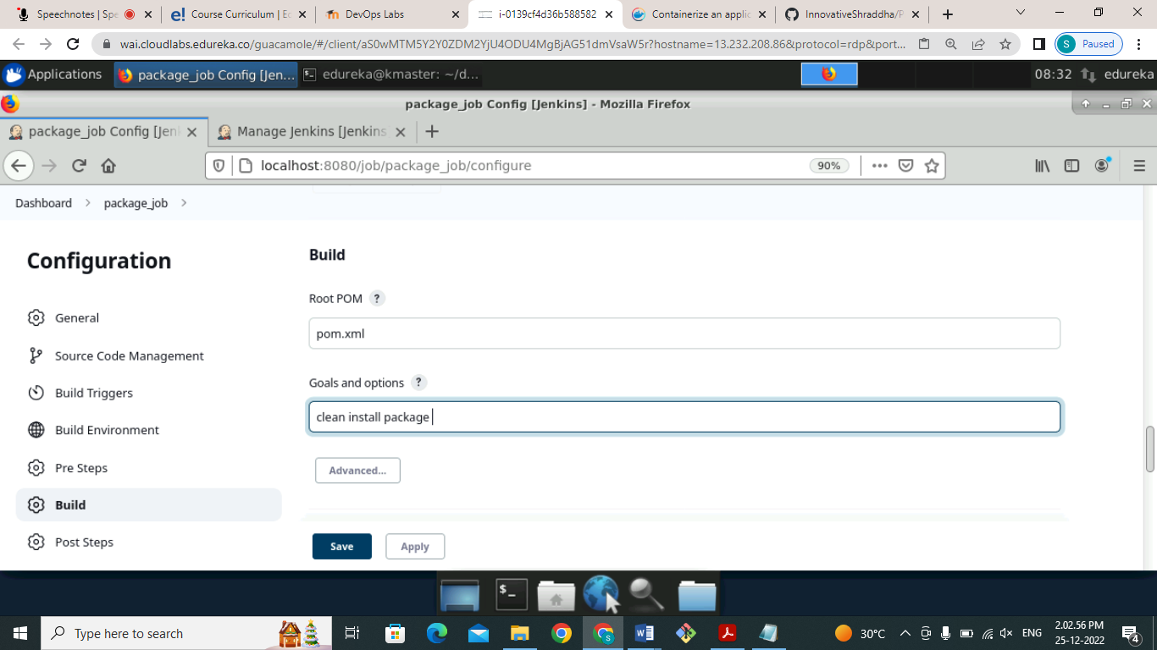

Then go to the **post build action** in that select option **send build Artifacts over ssh** as shown in below figure

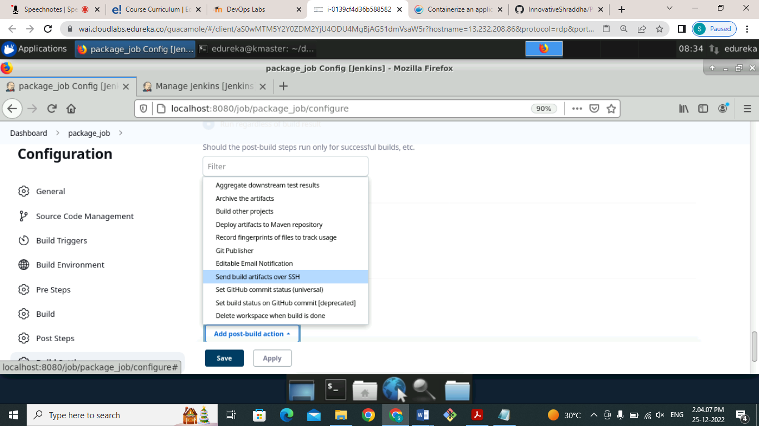

Provide the name of the ssh server and the files that we want to you send through the Jenkins that is WAR files as shown below

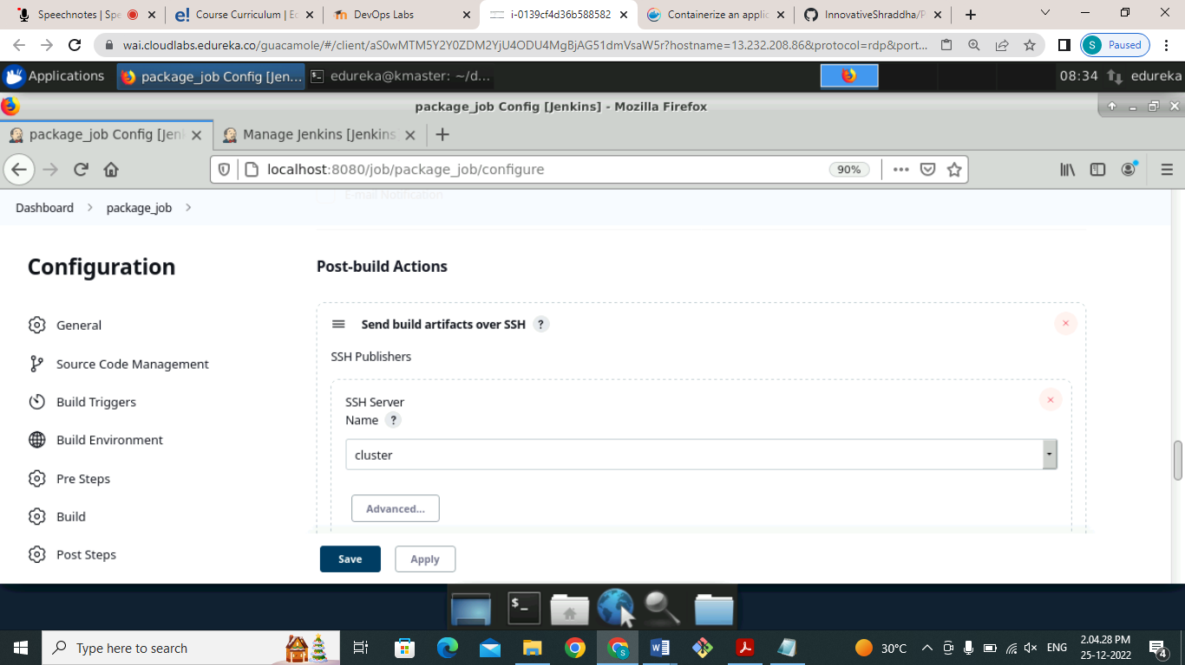

Give the name of files that I want to send through artifacts over ssh as shown below

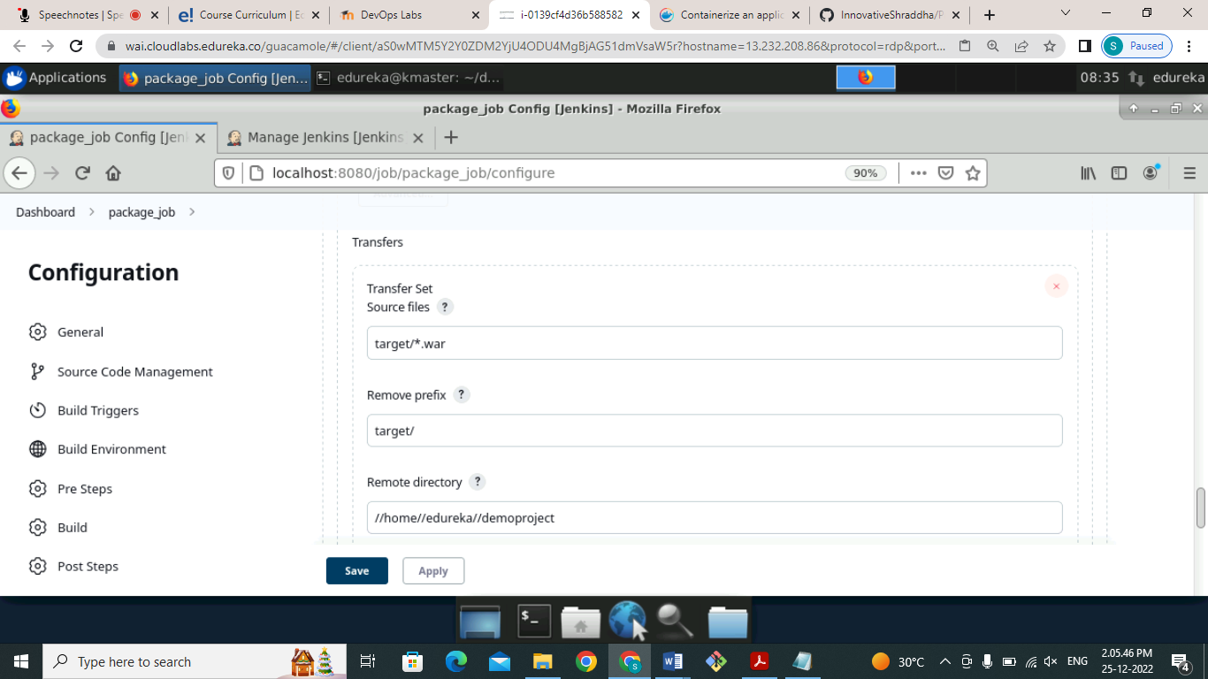

Click on the **save** button after success after filling the details and build the project we can see that our job built successfully as shown in below screenshot

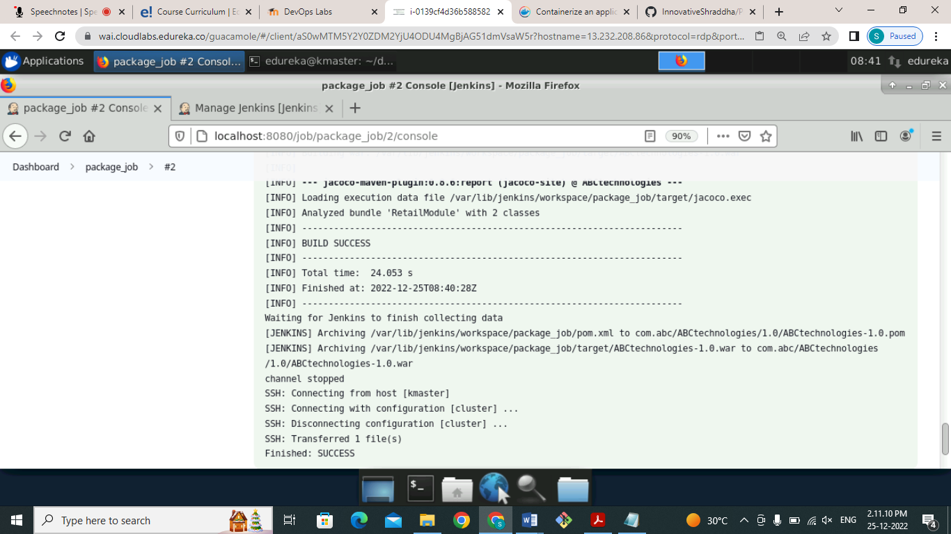

If we want to validate then go to the demo project folder and check whether a war file is copied or not as shown below figure

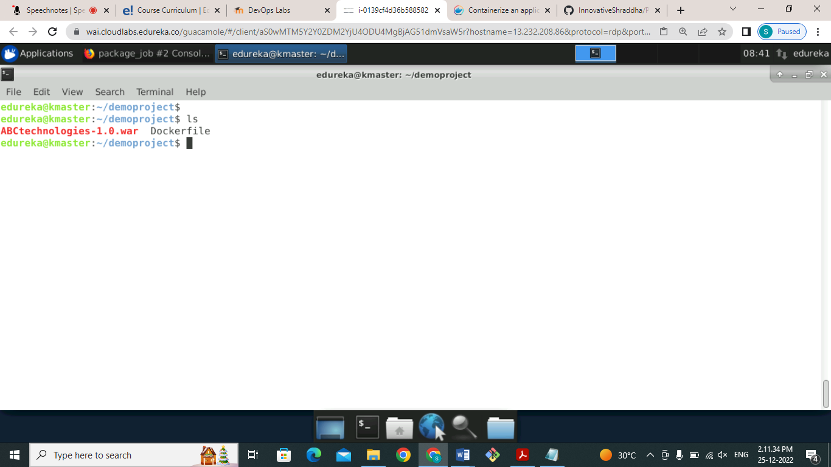

We can see that our war file successfully copied now go to docker hub registry to create repository where we can Store our image file that we will push from docker.

Create a repository as shown in below screenshot

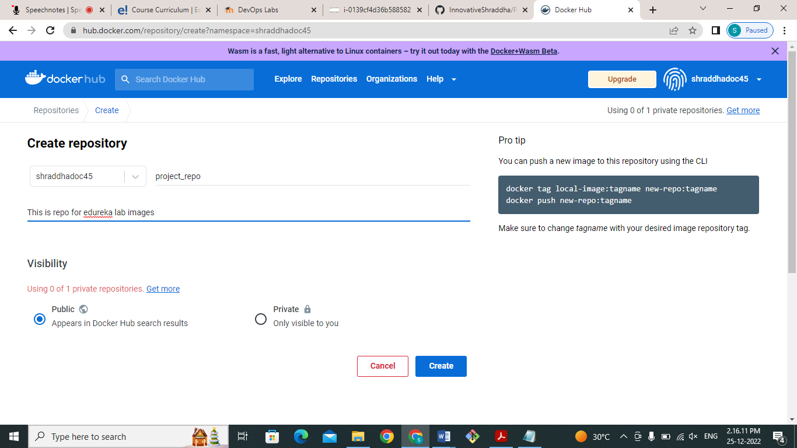

Click on create and we can see that our repository of name **project_repo** is created successfully now we want to push our image into this repository as shown below

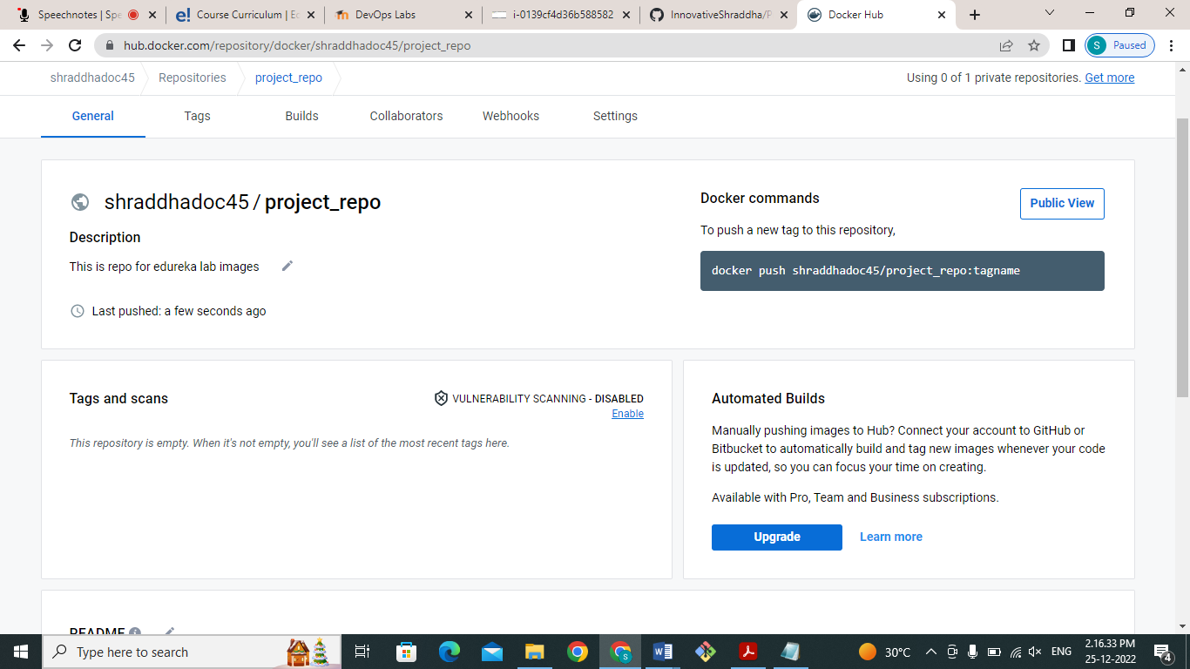

We need a Docker file to create an image and push it on docker hub registry.I have created Dockerfile as shown in screenhot.

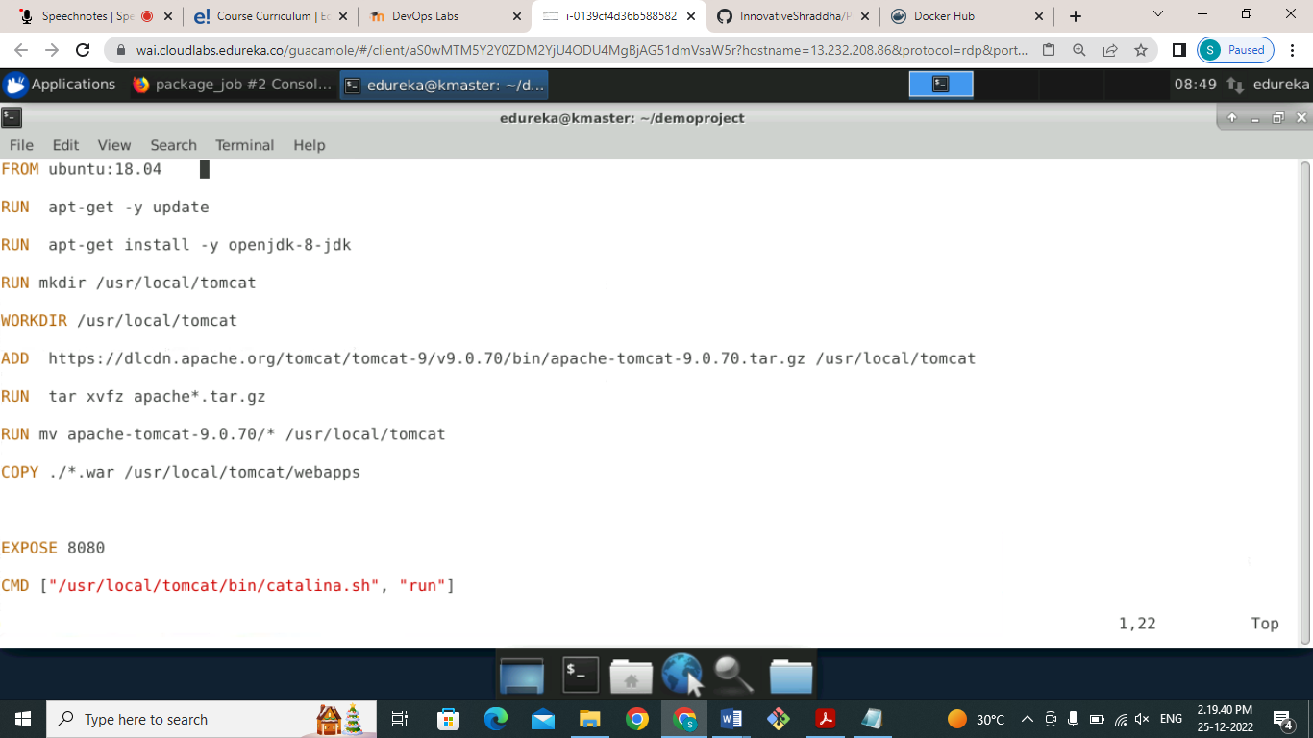

First, we will build that image using my image: v1 as shown below screenshot

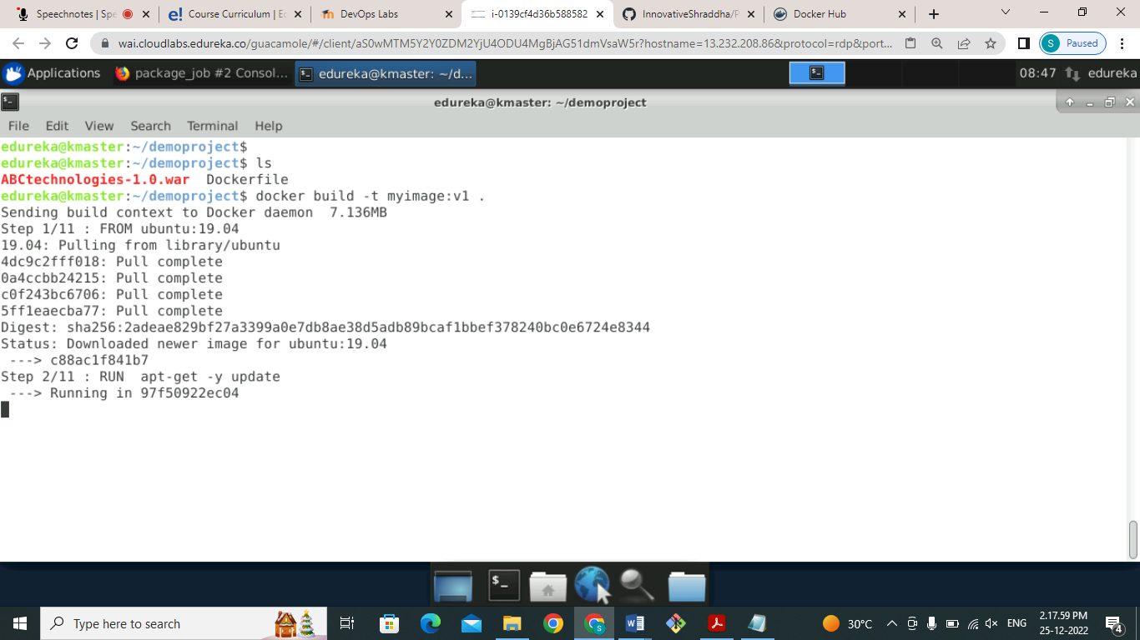

We can see that our image builds successfully as shown below screenshots and tagged the image as

Myimage:v1 .

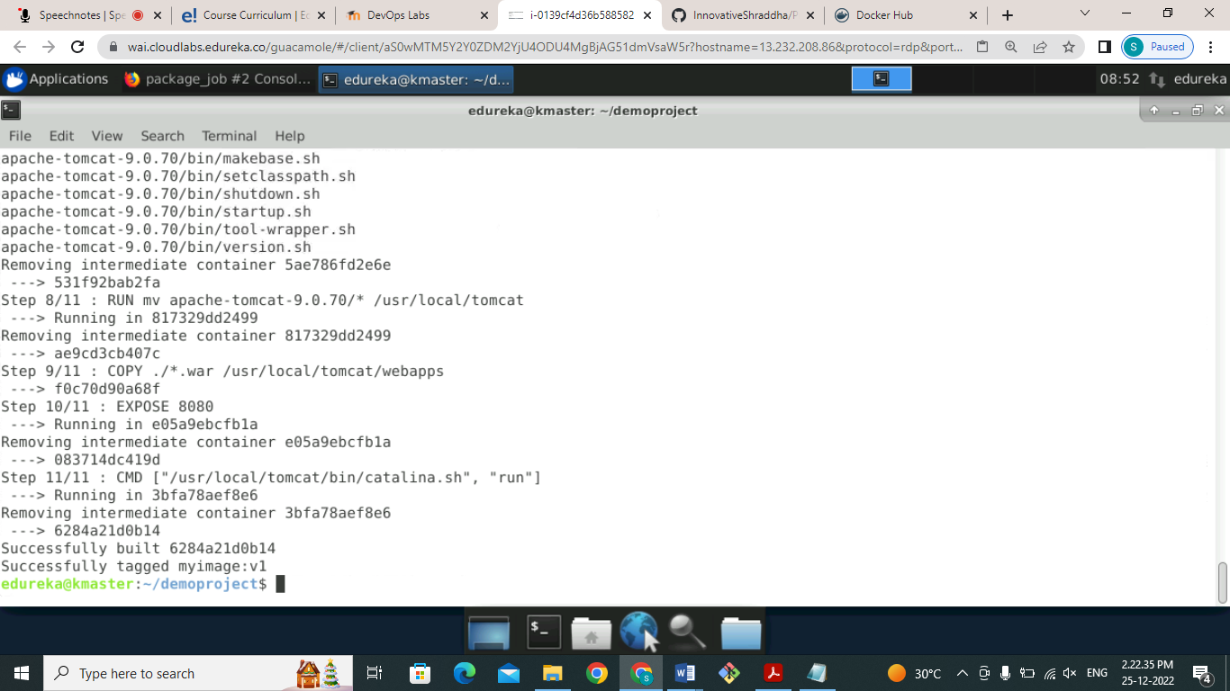

We can validate image using docker commands as shown below

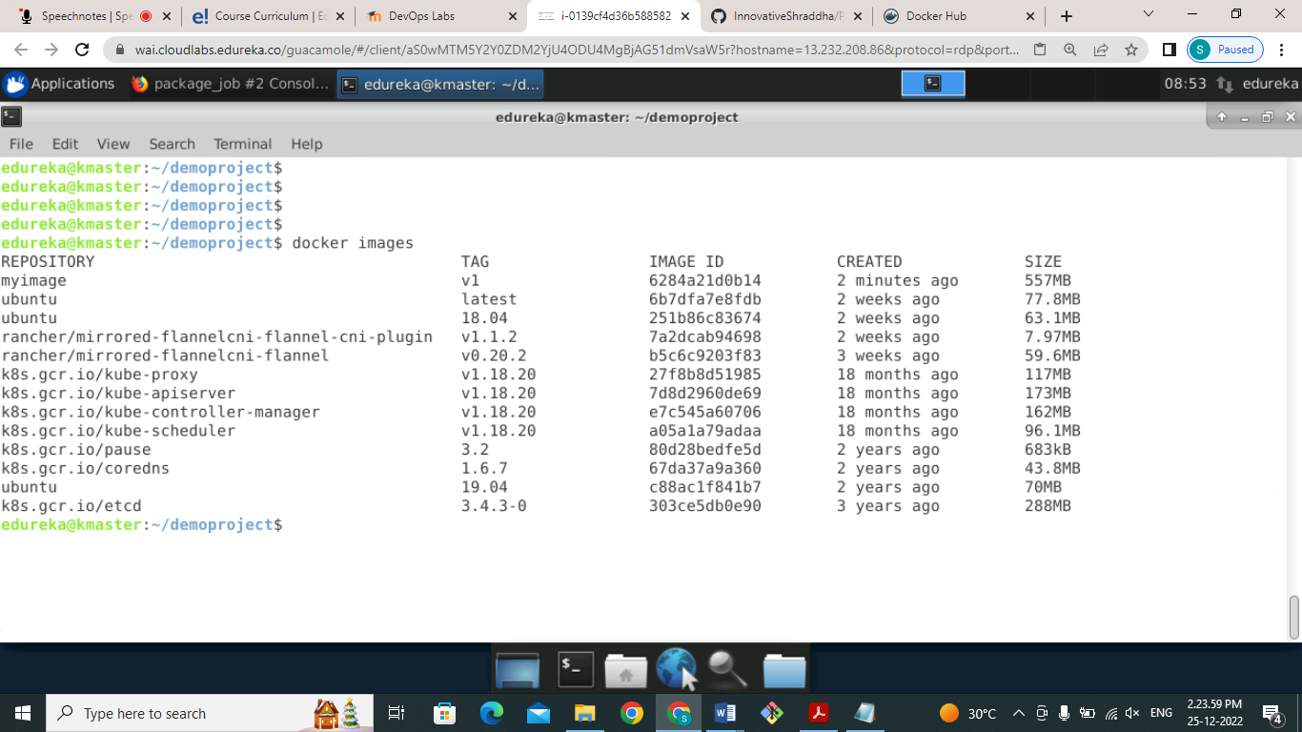

To push images in to docker hub registry we need to login first using docker cli from local ,use following commands as shown below figure

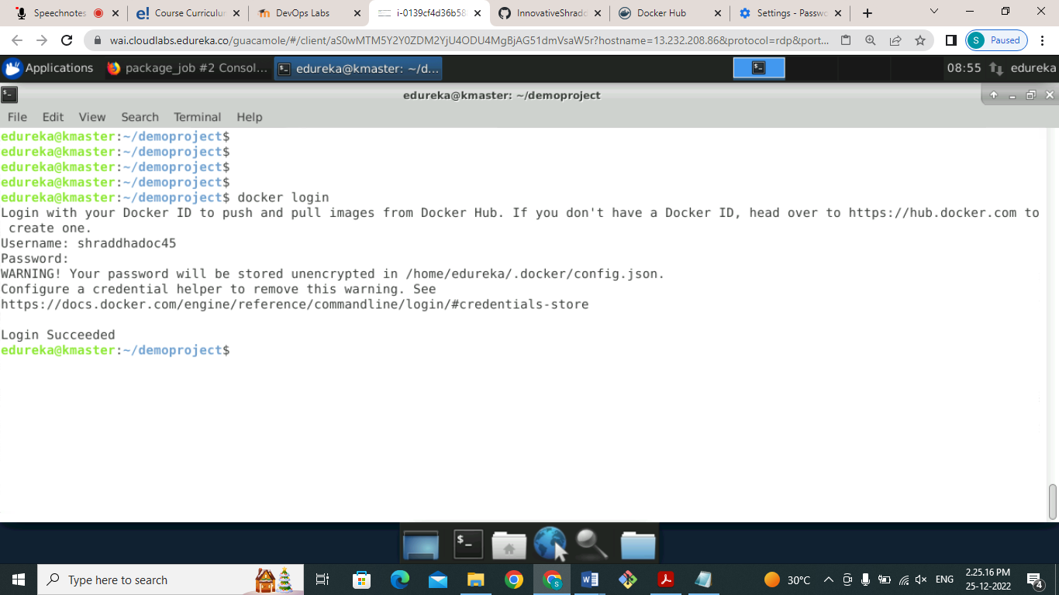

After login successfully, we can tag our image for pushing to docker hub registry as shown below figure

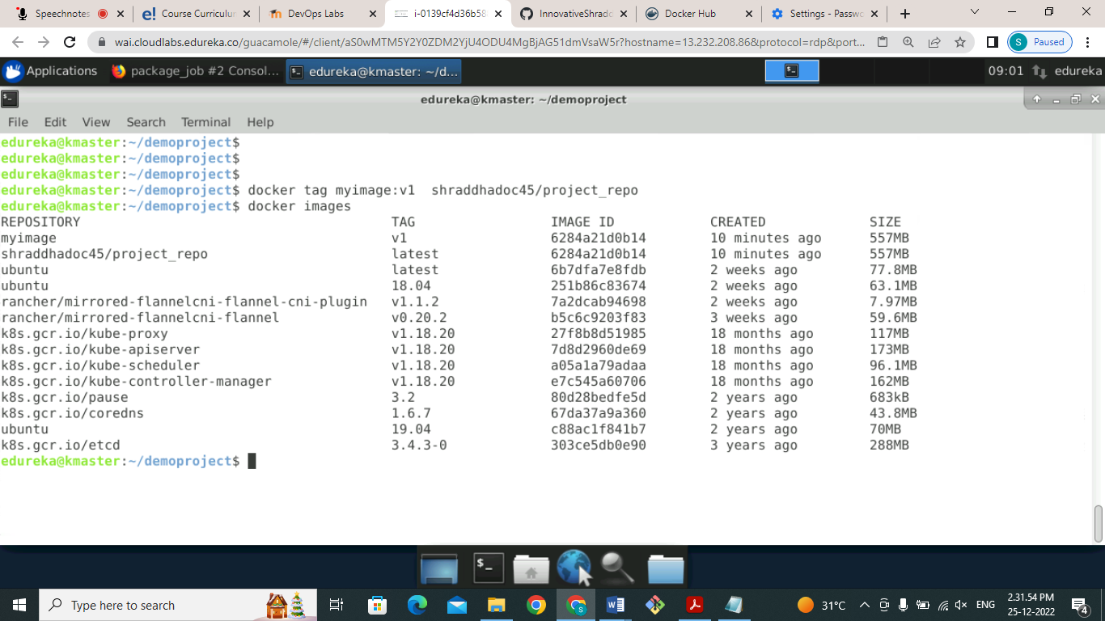

Now use docker push command to validate that our image is pushed or not, from fig we see our docker imaged pushed successfully.

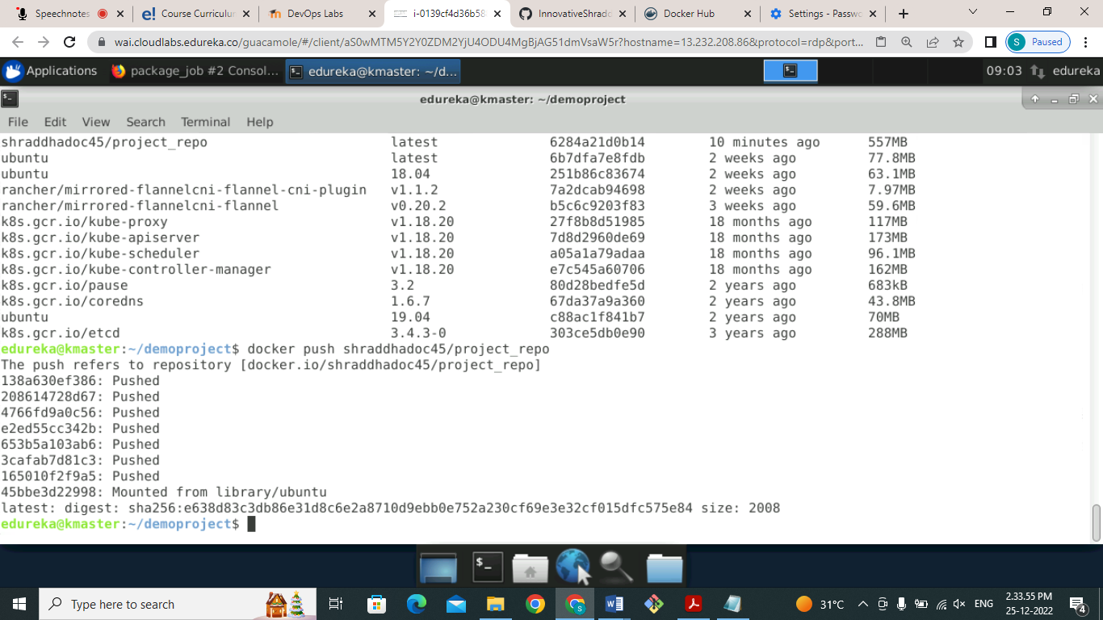

Now to validate go to docker hub registry and check weather uh image is push or not from screenshot we can see that our image successfully

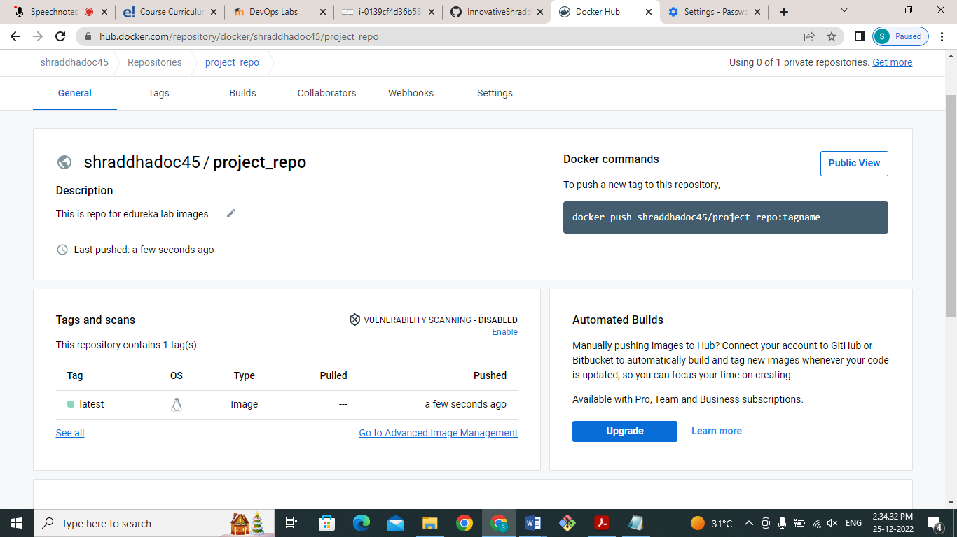

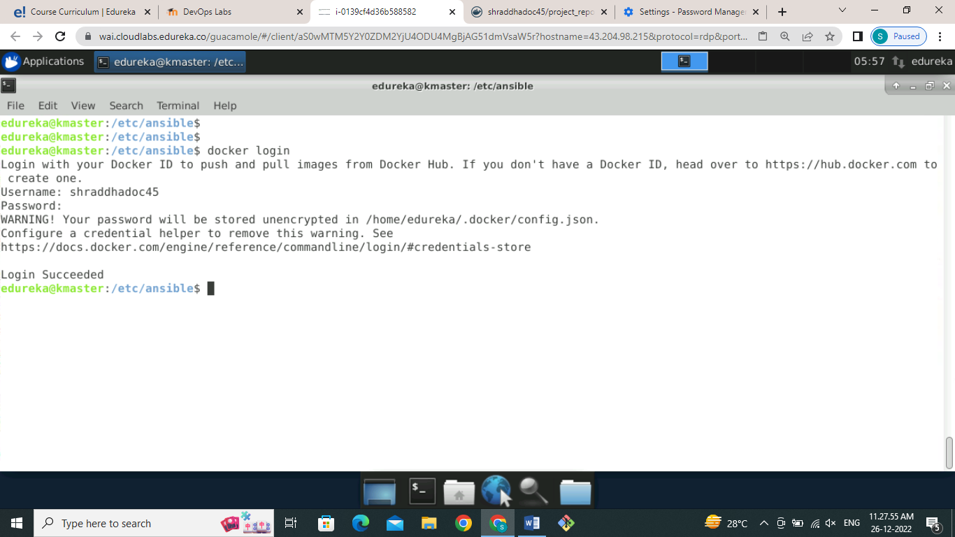

You can also use **playbook** to push image into docker hub registry but for that we need to provide our login ID and password of Docker hub registry into Playbook which is not safe and secure. is I simply login from my serial to the docker hub registry and return of Playbook push my image into docker hub registry as shown below screenshots

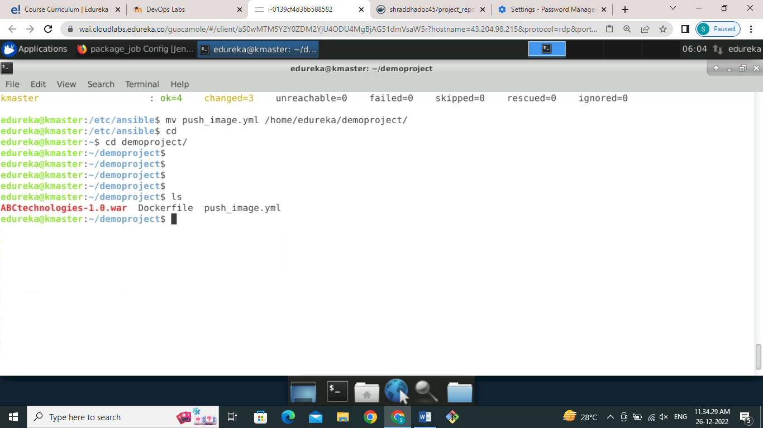

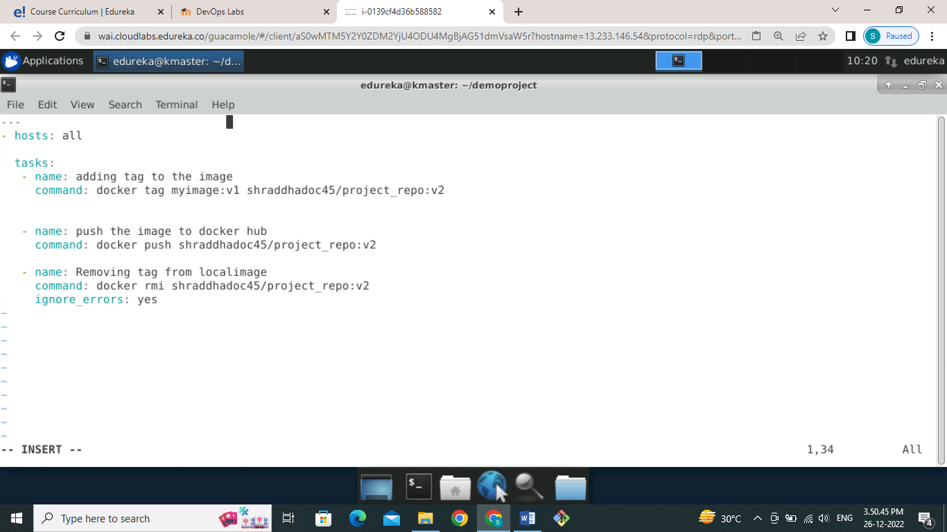

Check the syntax of the Playbook and run Playbook using ansible Playbook command

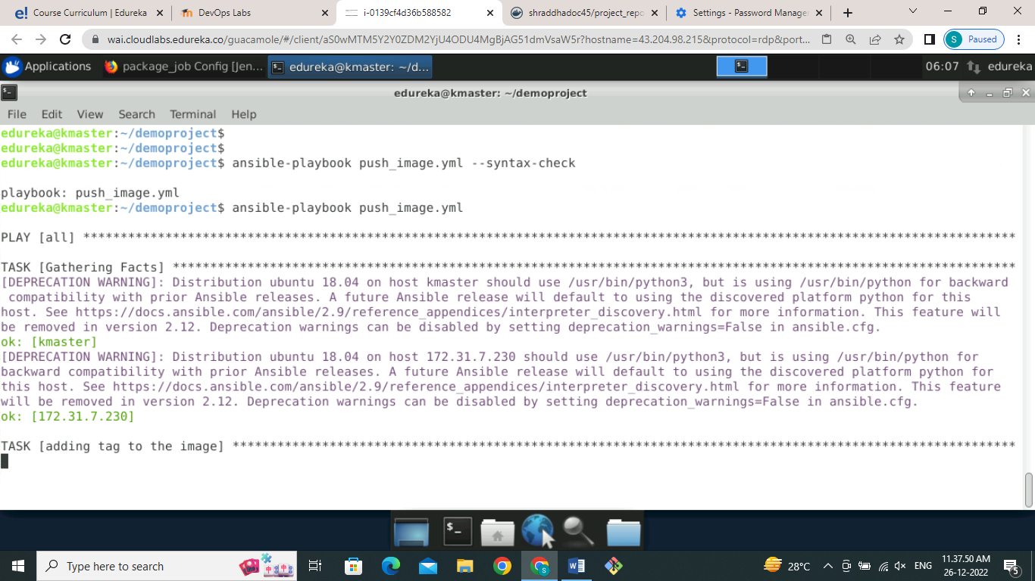

We can see that our Playbook executed success successfully and removing image from local that was tag to myimage:v1 .

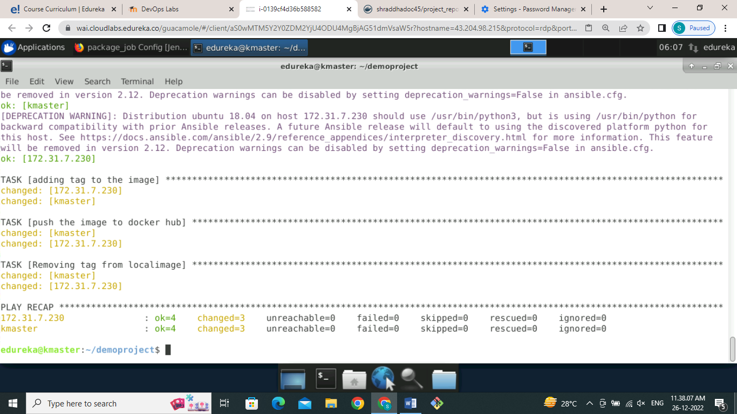

To validate go to the docker hub registry and check the repository there we can where we have push image so virgin one image is pushed successfully into project report repository as shown below screenshot

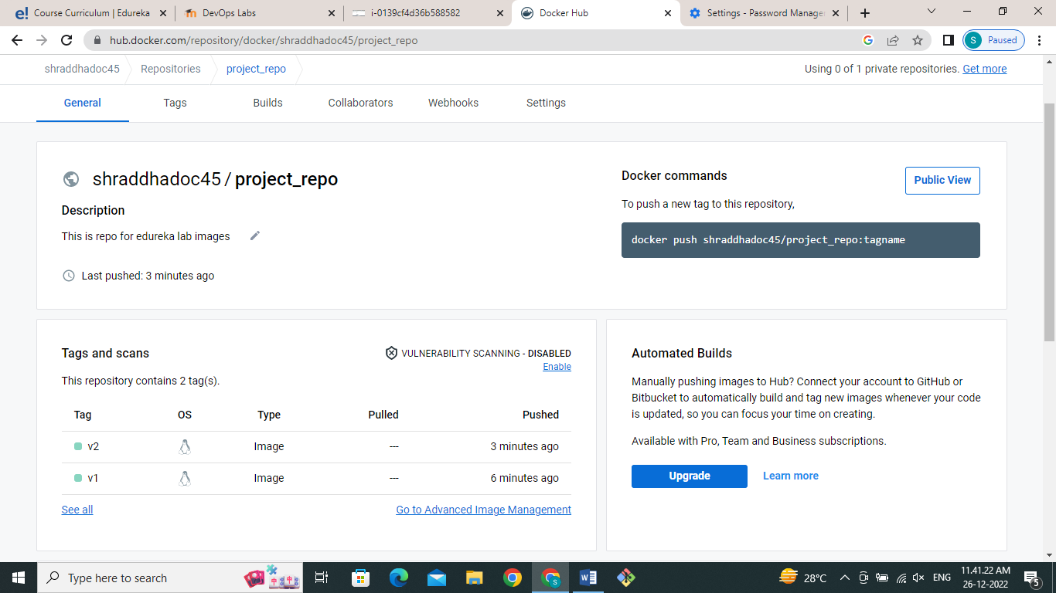

Now to push this image using Jenkins job go to Jenkins dashboard in the package of configure section in the post build action write the below command that shown in figure run play book for pushing image into docker registry as shown in screenshot

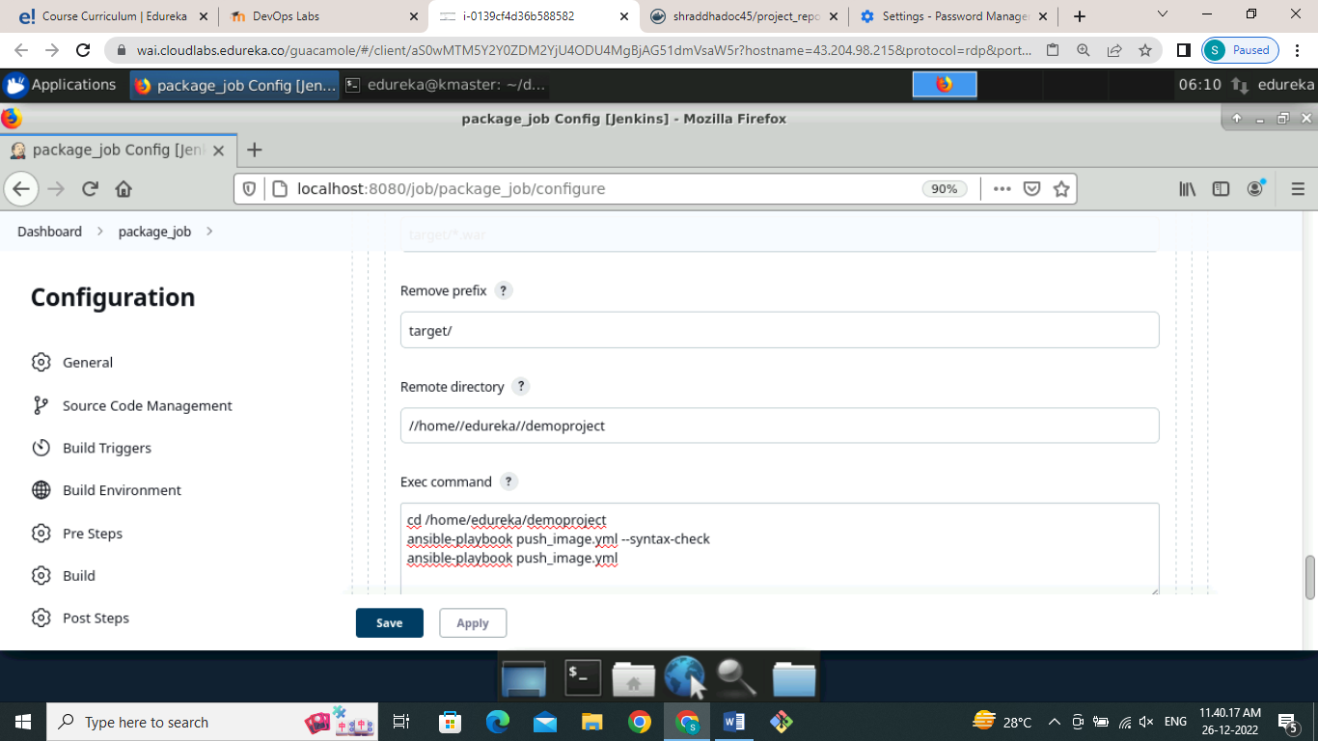

Save the configuration and build the job it will successfully build as shown below figure

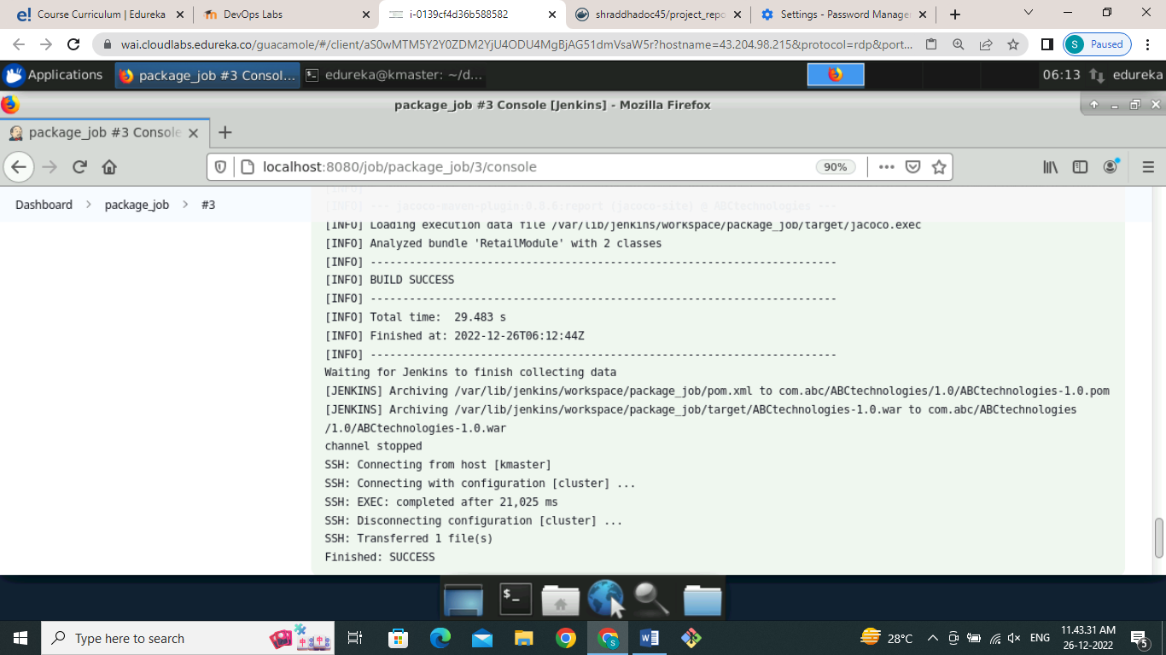

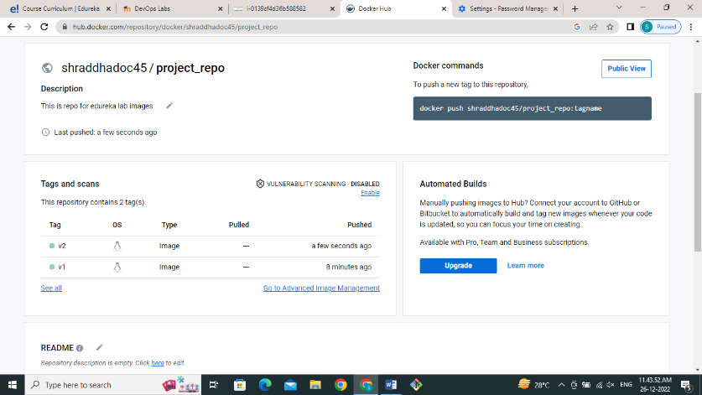

**3) Deploying on kubernetes cluster:**

For deploying artefacts on kubernetes we will writer deploy yammer file as shown below screenshot

And also write the service file to access the container the deployment as shown below screenshot

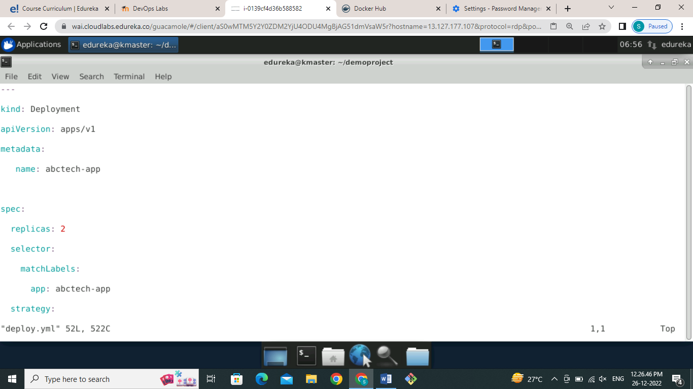

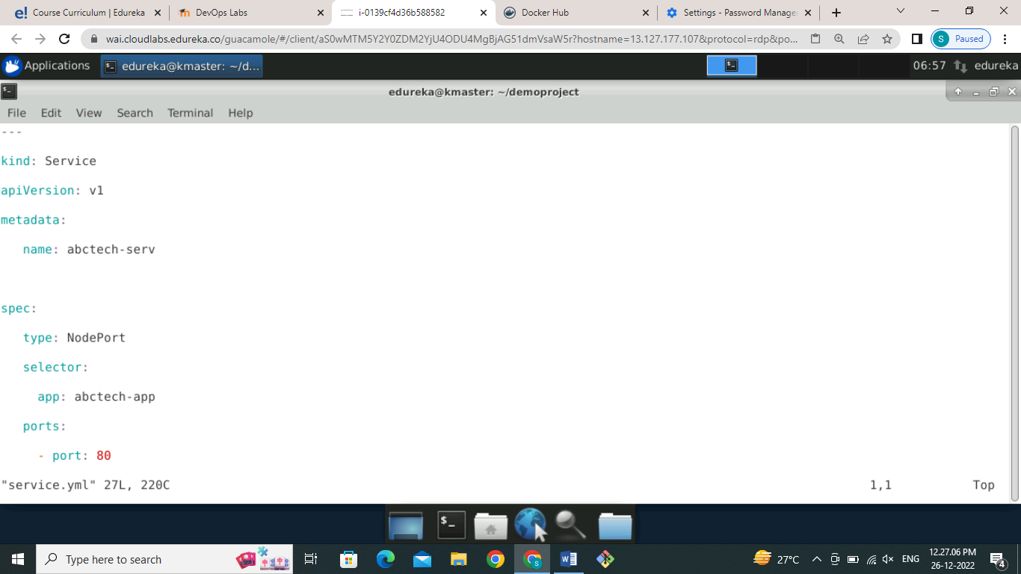

Now for deployment create a Jenkins job of freestyle as shown below figure

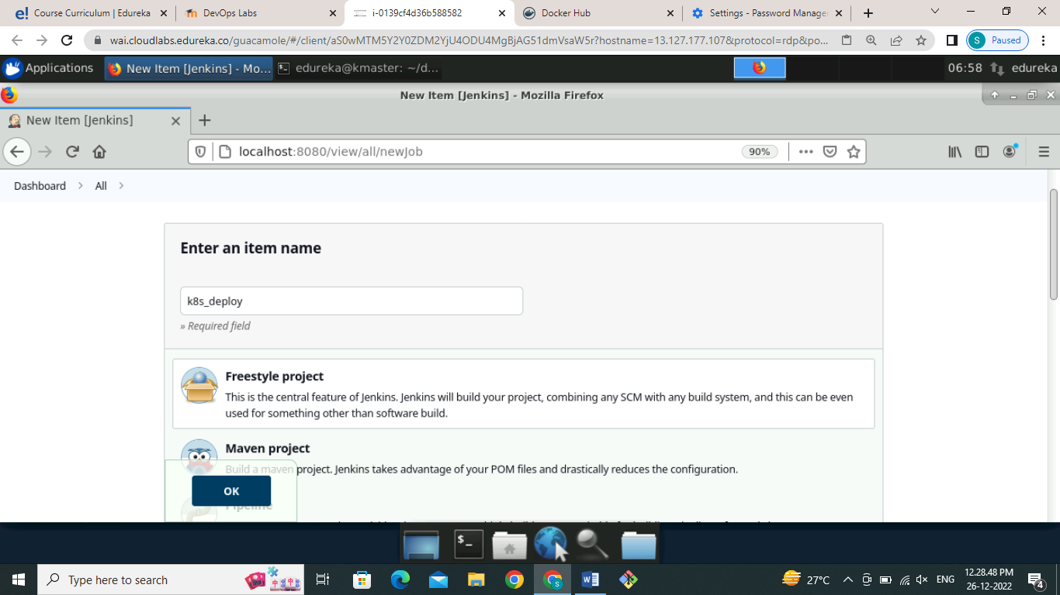

Go to **configure** section and select **build environment** in that select **set up of kubectl** as shown below screenshot.

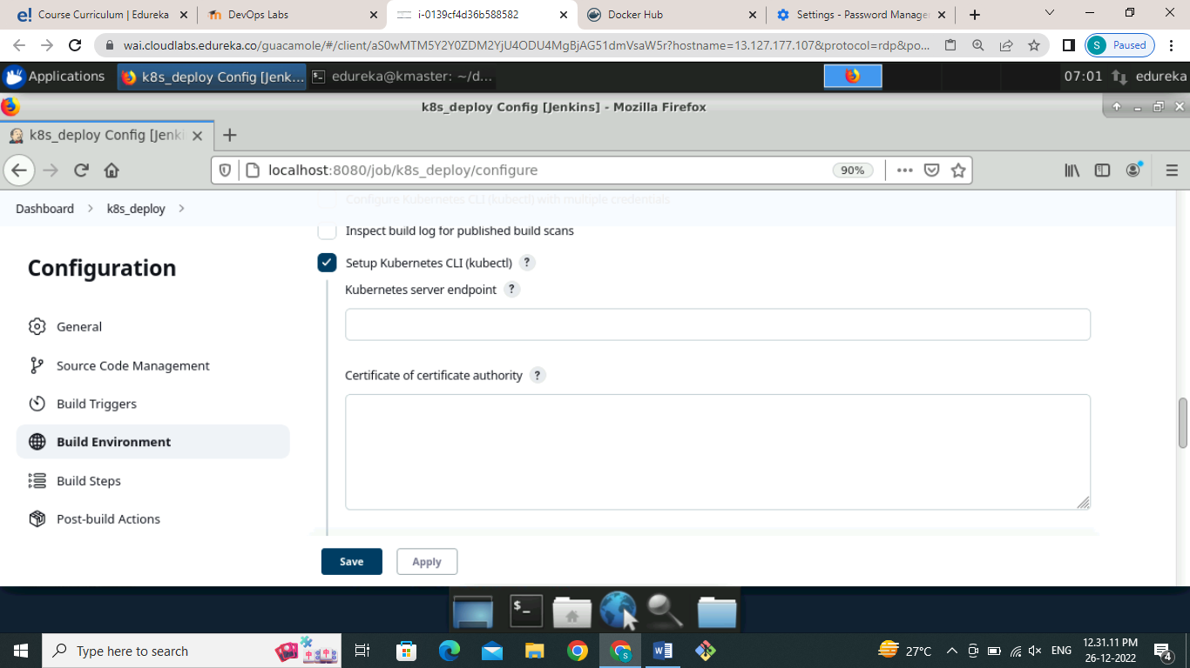

Provide credential as admin.conf as shown in figure below

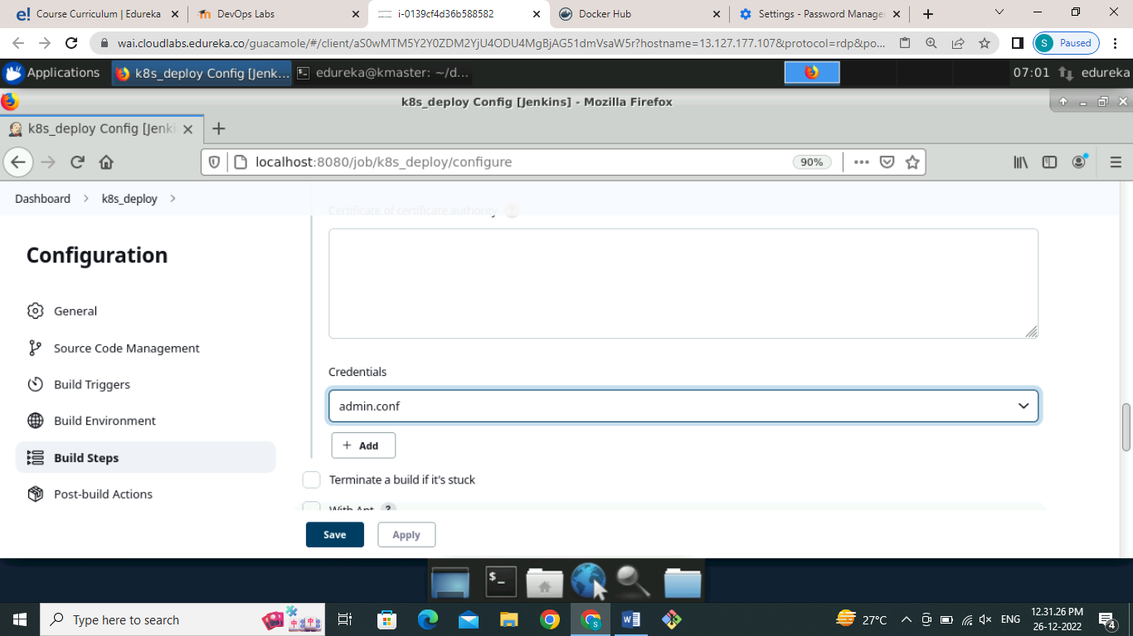

Now in the build step select **execute shell** and provide **kubectl** commands as shown in figure

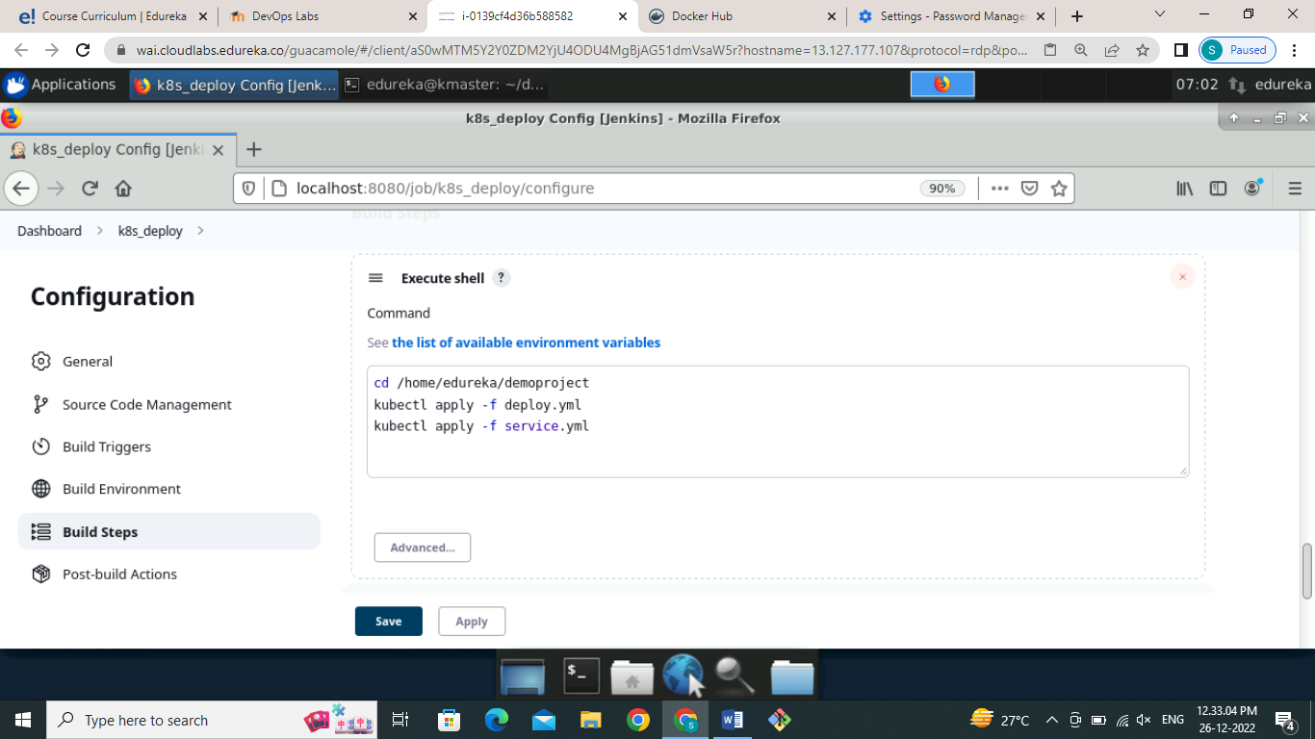

Click on **save button** and build the job ,it will build successfully as shown in figure.

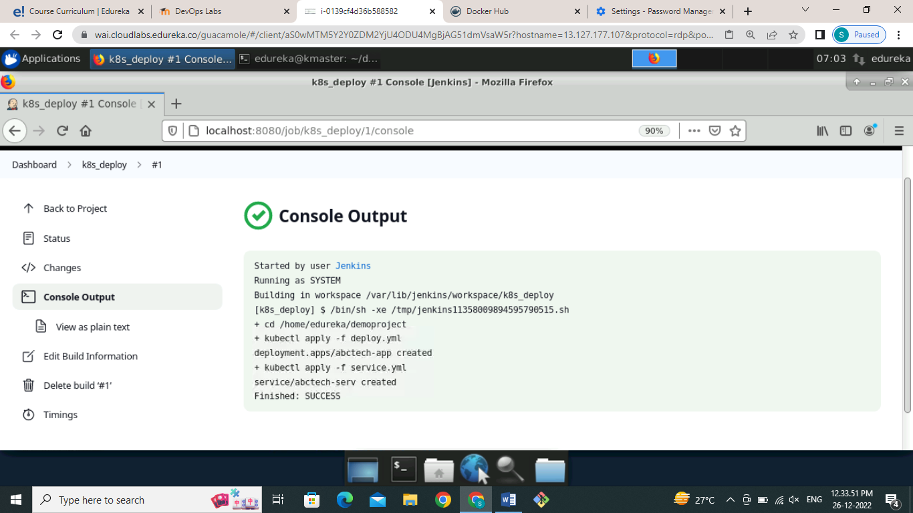

To validate that h deployment is successful youth following kubectl commands as shown below screenshots.

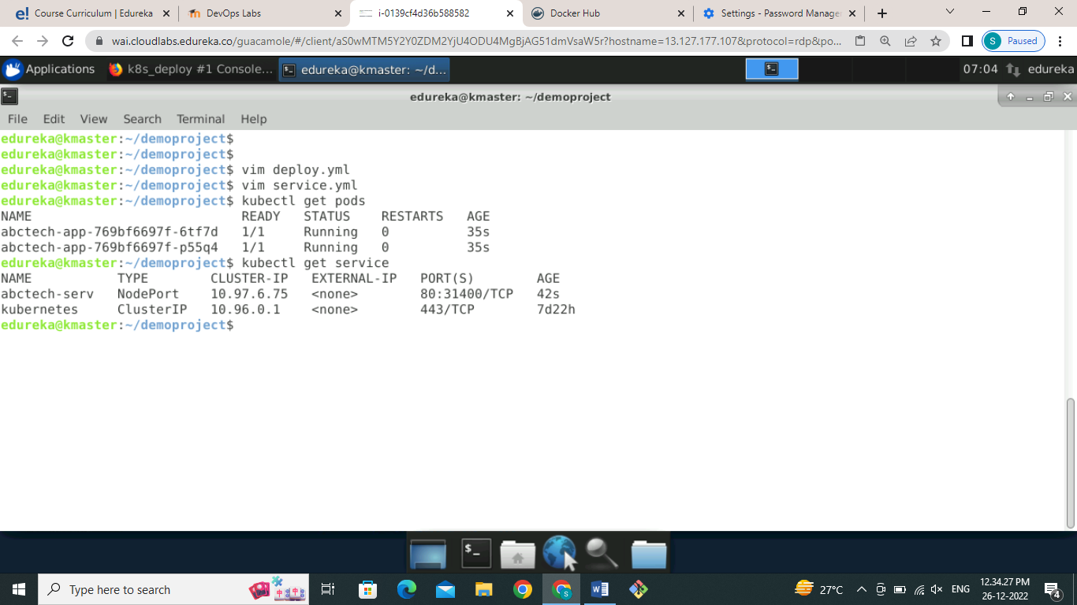

Now to access our applications from browser use IP address of your machine along with that port number as shown in below screenshot

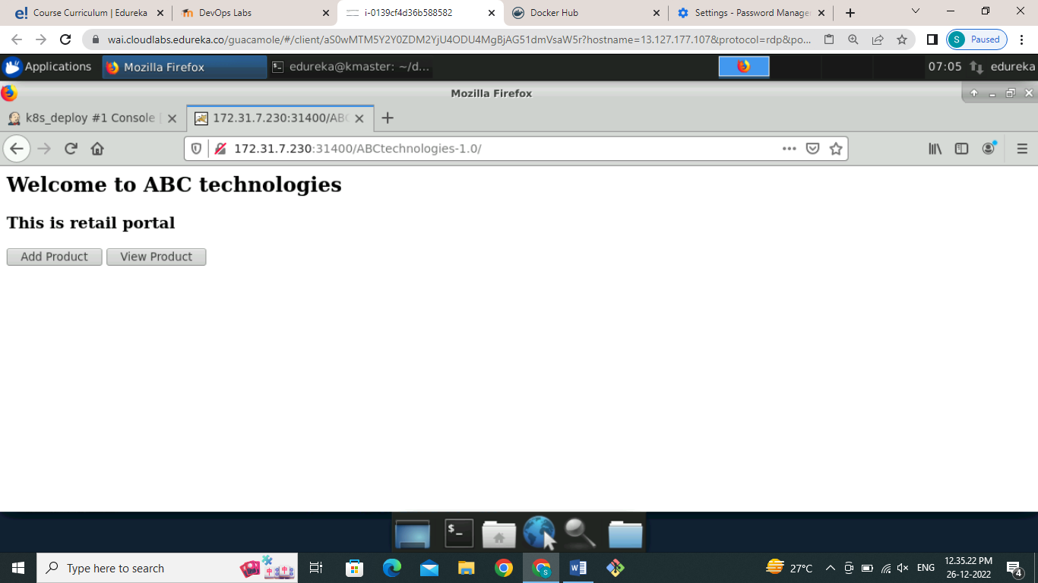

Now our application deployed successfully, now we want to build a pipeline for that we need to install some pipeline plugin plugins as shown in below screenshots. I have used build pipeline plugin and pipeline plugin as shown in figure

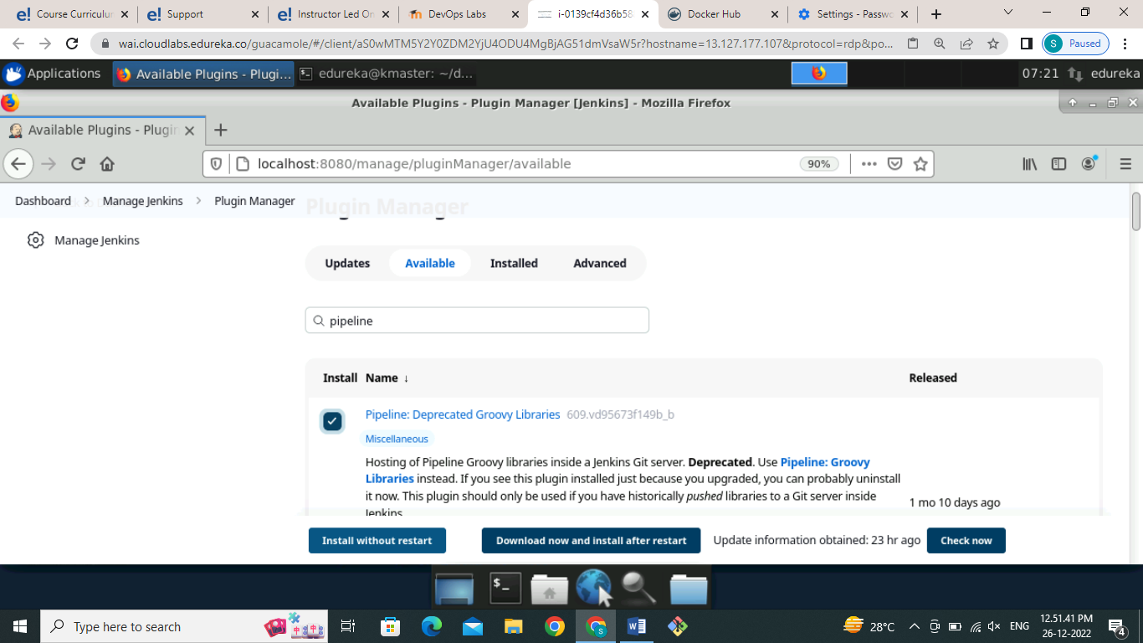

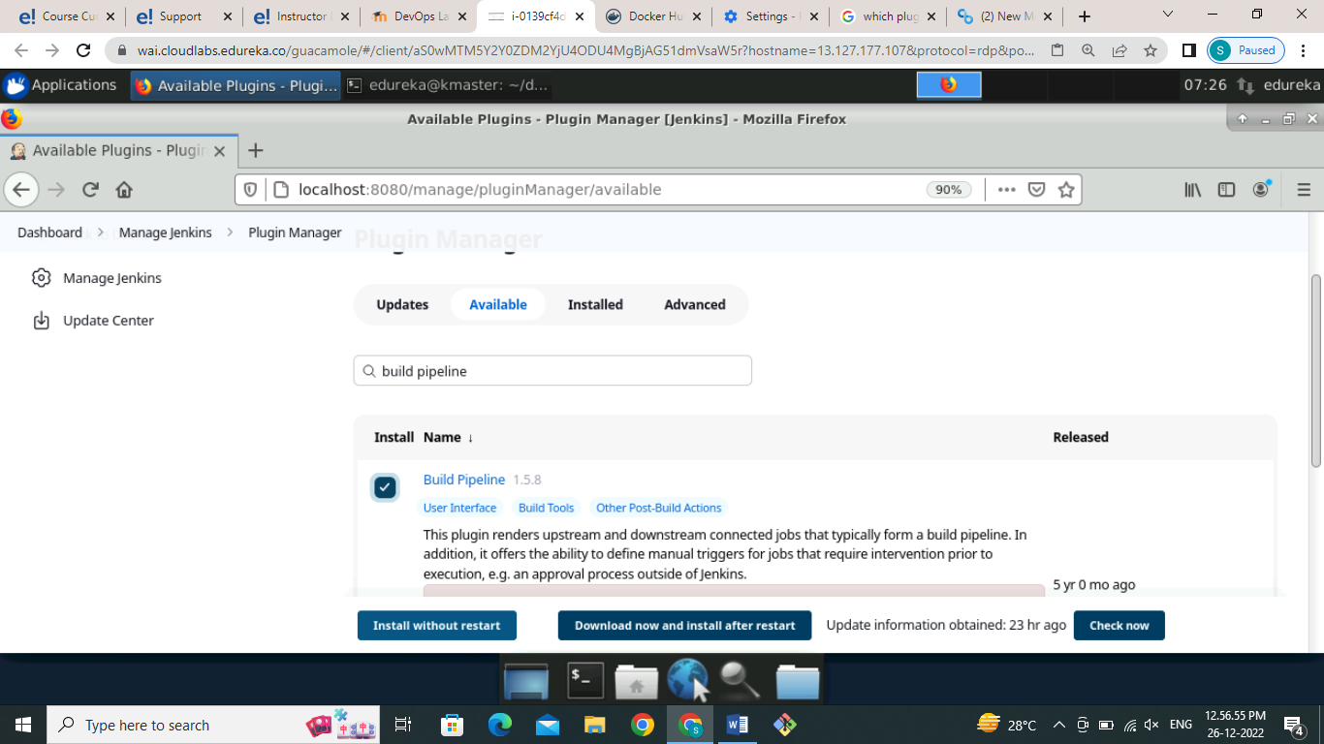

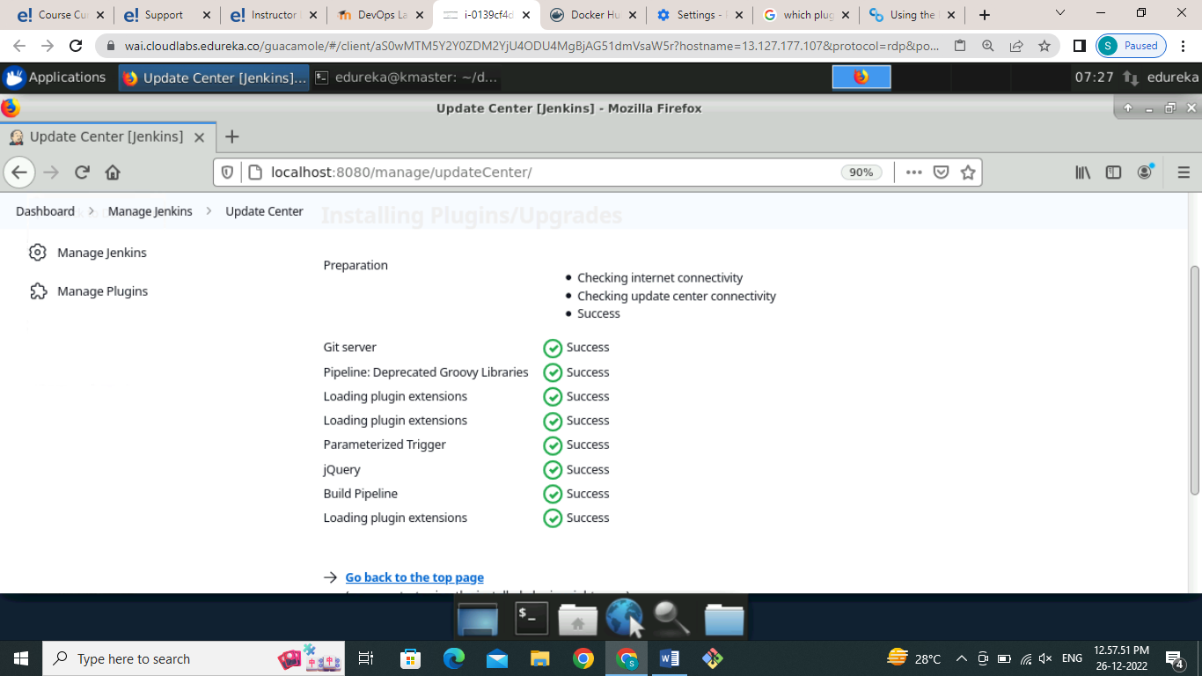

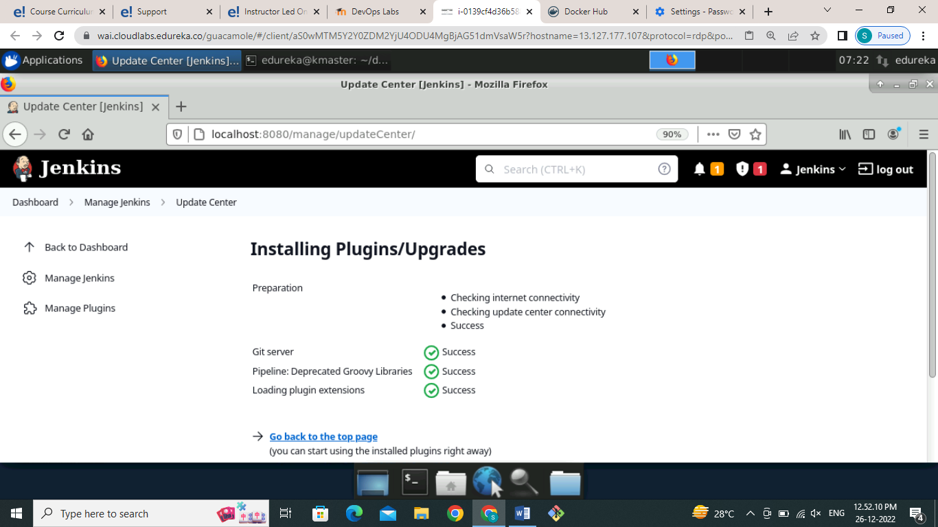

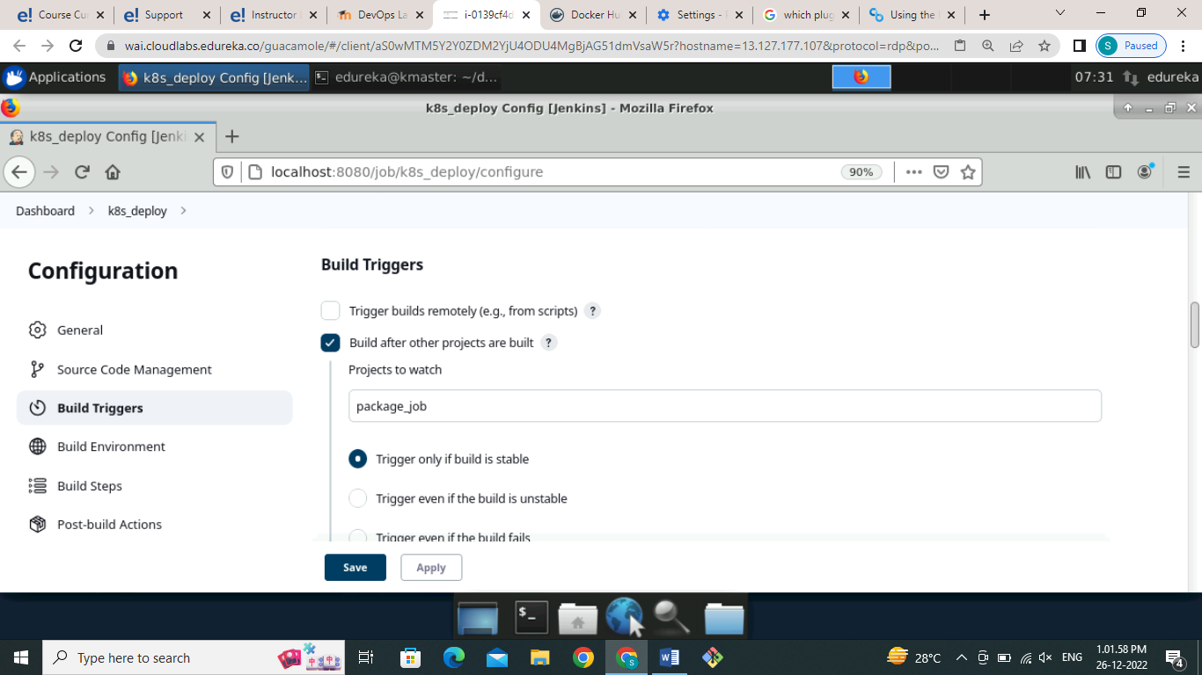

Now we want the Jenkins job into upstream and downstream to make a pipeline for that go to **k8s_deply** job in the configure section select **build triggers** and in that provide the name of the job that we want to execute after the build project as shown in figure

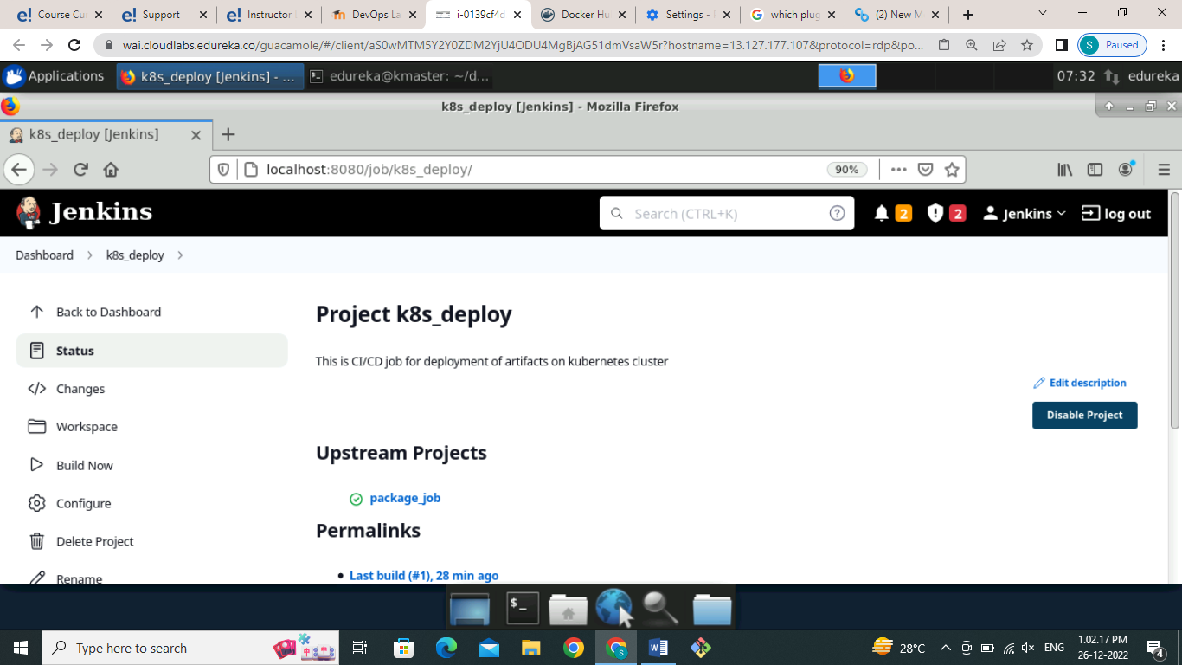

We can see that upstream and downstream projects are created has shown in screenshot now we will create a pipeline to view and execute job.

**4) Create a CI/CD Pipeline job:**

How to create a pipeline click the Plus sign that shown in in dash it will open new page to create a view pipeline in that select build pipeline view give the name and click on create button as shown below figure.

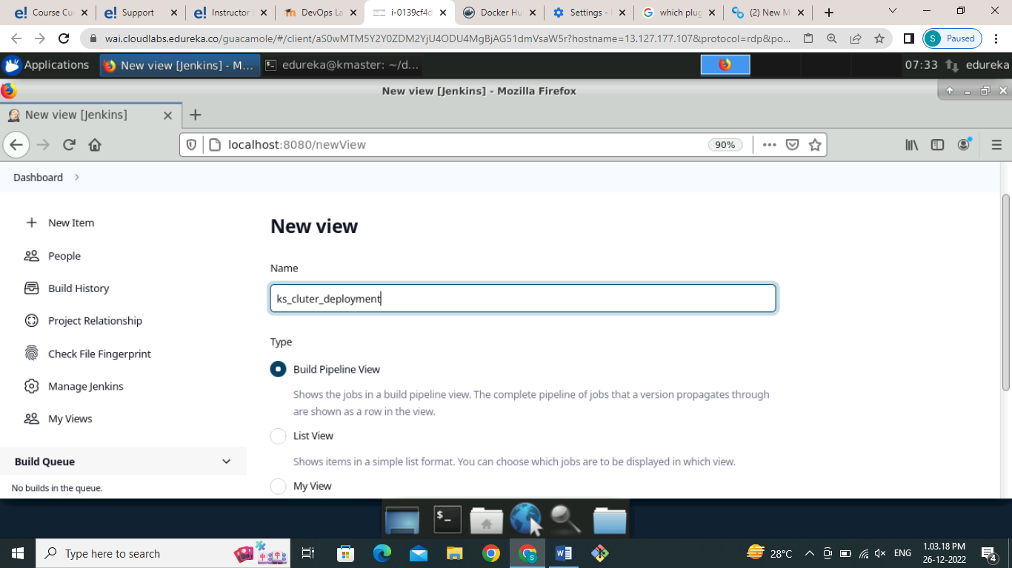

Go to the **layout** section and select base on upstream downstream config provide the name of job that we want to initiate our pipeline so I have provided the **package_job** name to start my pipleline

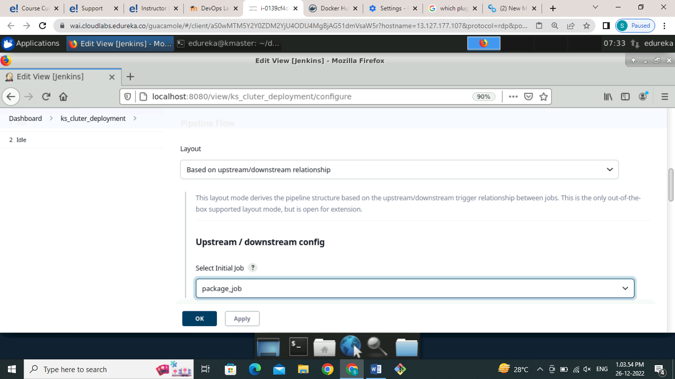

Click on save button and it will open the build pipeline dashboard where we can see e h pipeline not started click on the run button to start pipeline as shown in below figure

The yellow colour indicates that the pipeline get executing blue colour indicates that pipeline not at started and green colour indicates executed successfully as shown in below screenshot

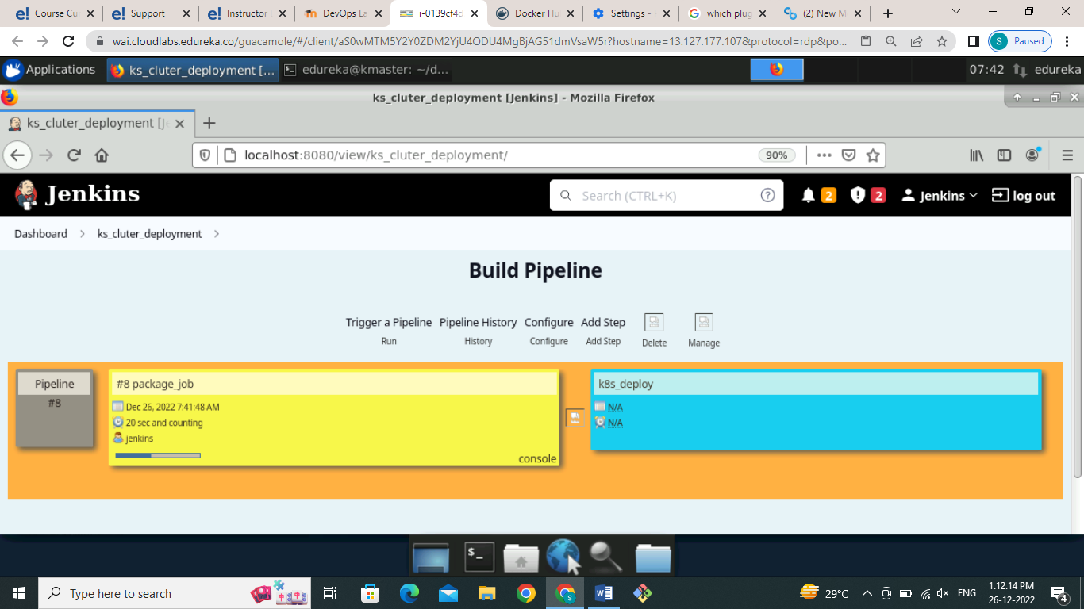

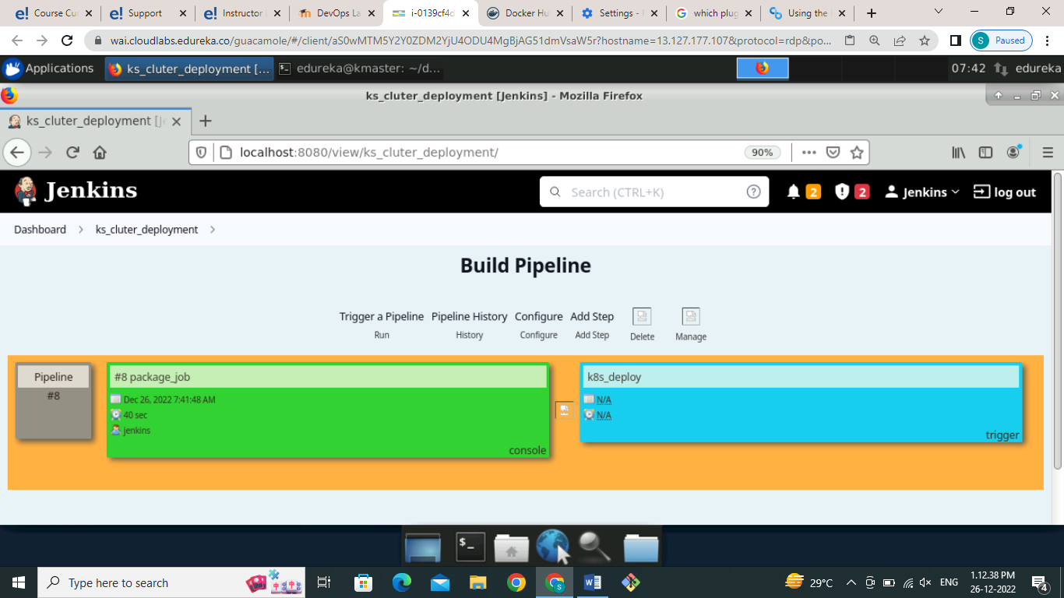

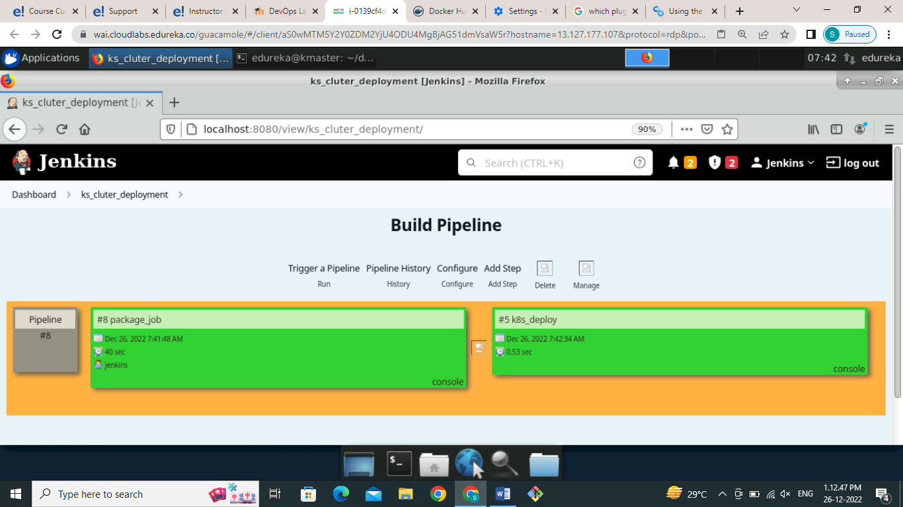

Nau to validate go to kubernetes cluster and use following commands to check deployment as shown in below figure

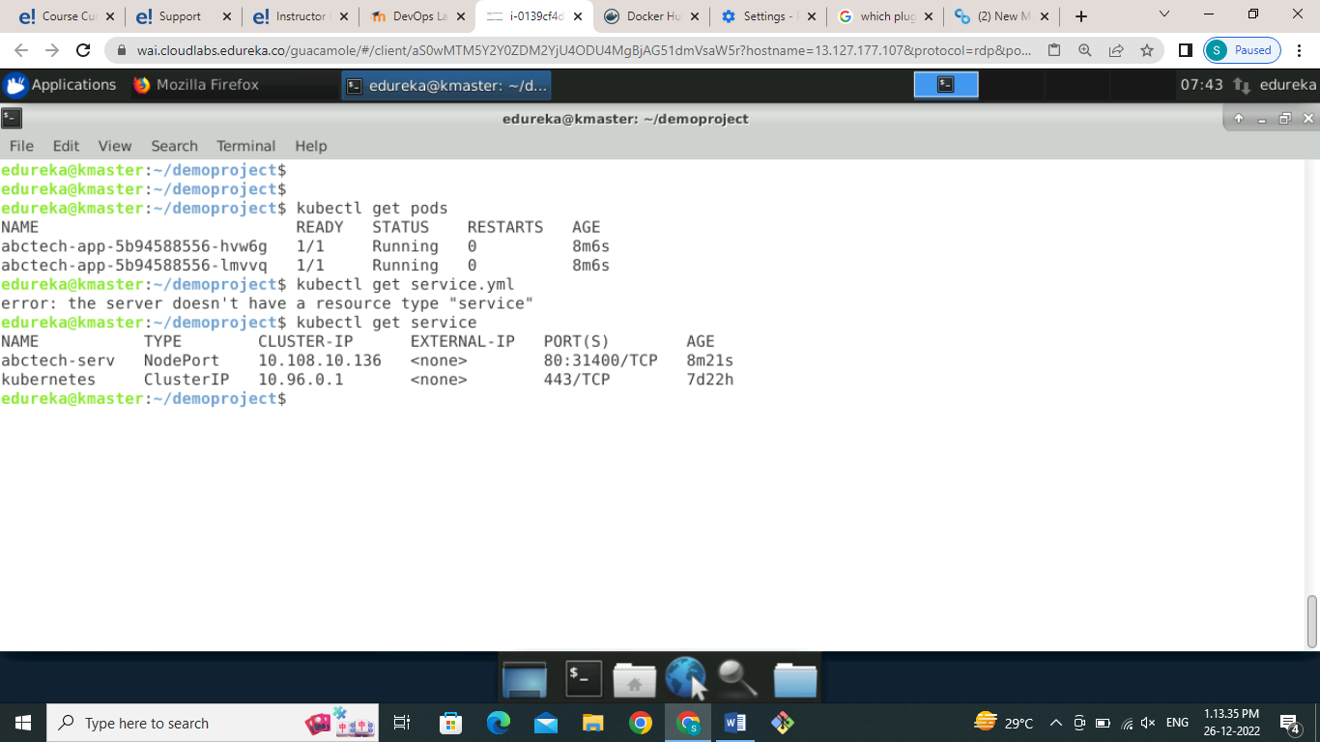

To validate from browser use your IP address and along with port number that are created by service as shown in below we can see that our deployment get successful.

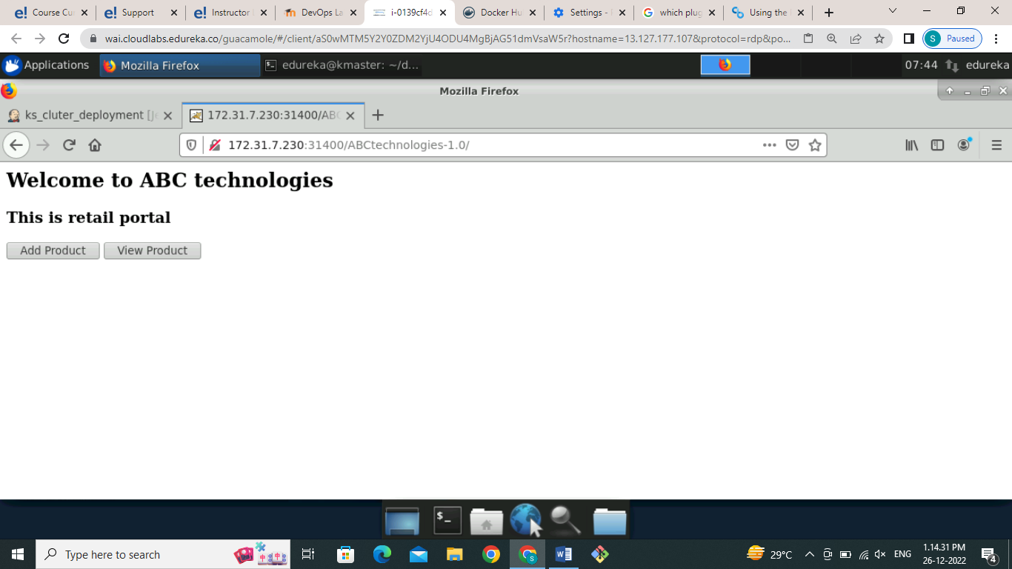

I have tried this method using ansible Playbook but it's giving me e following error which I have mention following screenshot.

I will share the ansible Playbook files for deploying using ansible and other files also.

